Srping REST API and Services

- create REST API/web service with spring

-REst Consepts JSON and HTTP messaging

- REST client tool postman

-Deveolp REST API with @RestController

-CRUD inteface through SPRING REST

Bussiness Problem

-Build Cleint app that provides wheather report to city

- need to get dat from external seervices

Application A/c

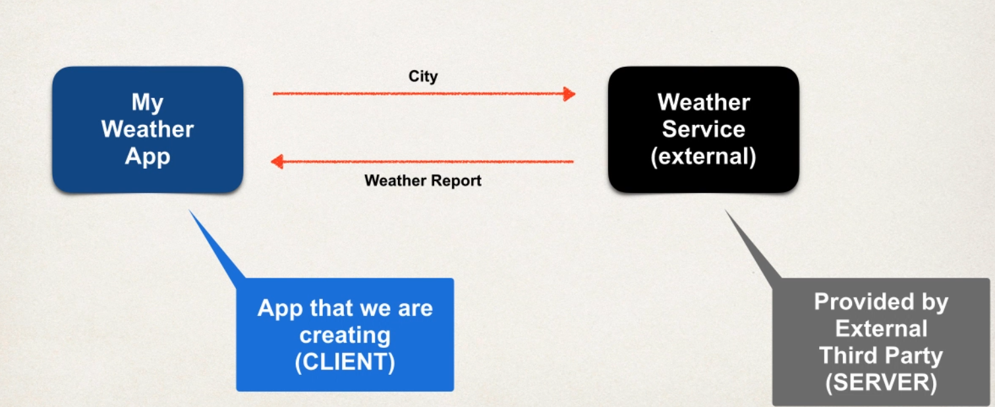

Question

1 how we connect to wheather service

2 whcih lang to use

3 data format

Ans:

1 we can use rest API call over http

REST: REpresentational State Transfer

Light weight approcah to communicate between 2 applications

2 Rest is lang independent

-client can use any prog lang and server can use any prog lang

3 Rest app can use any data format common used XML and JSON. JSON is most commonly used

JSON: Java SCript Object Notation

Solution

Free wheather service by openweathermap.org

Call wheather service API doucmnetion gives

By passing city name:

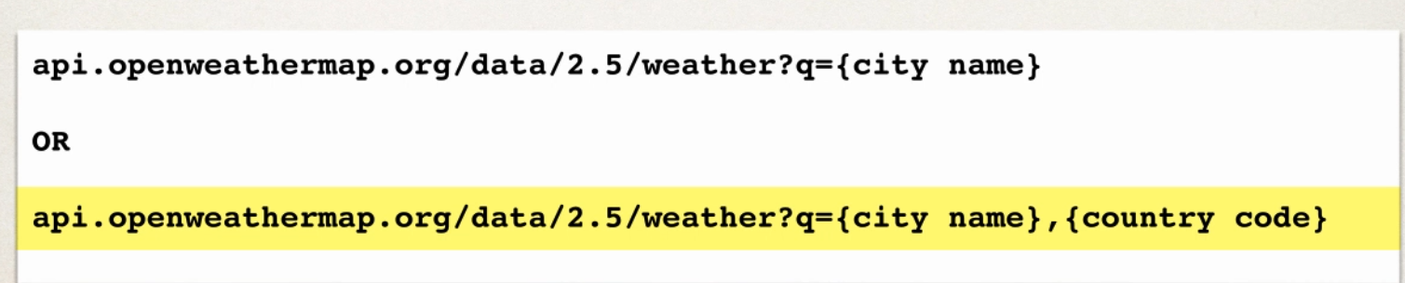

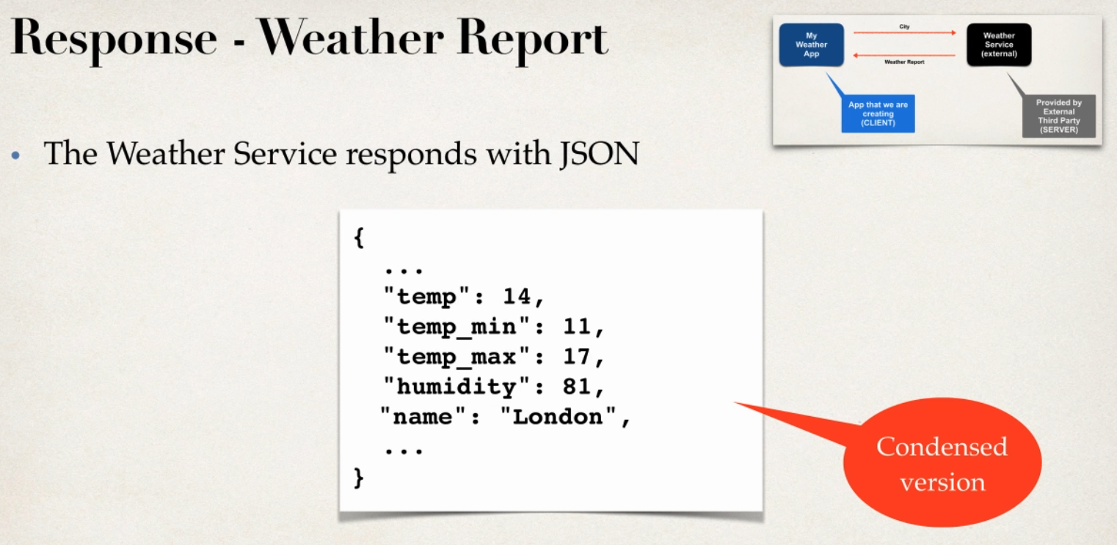

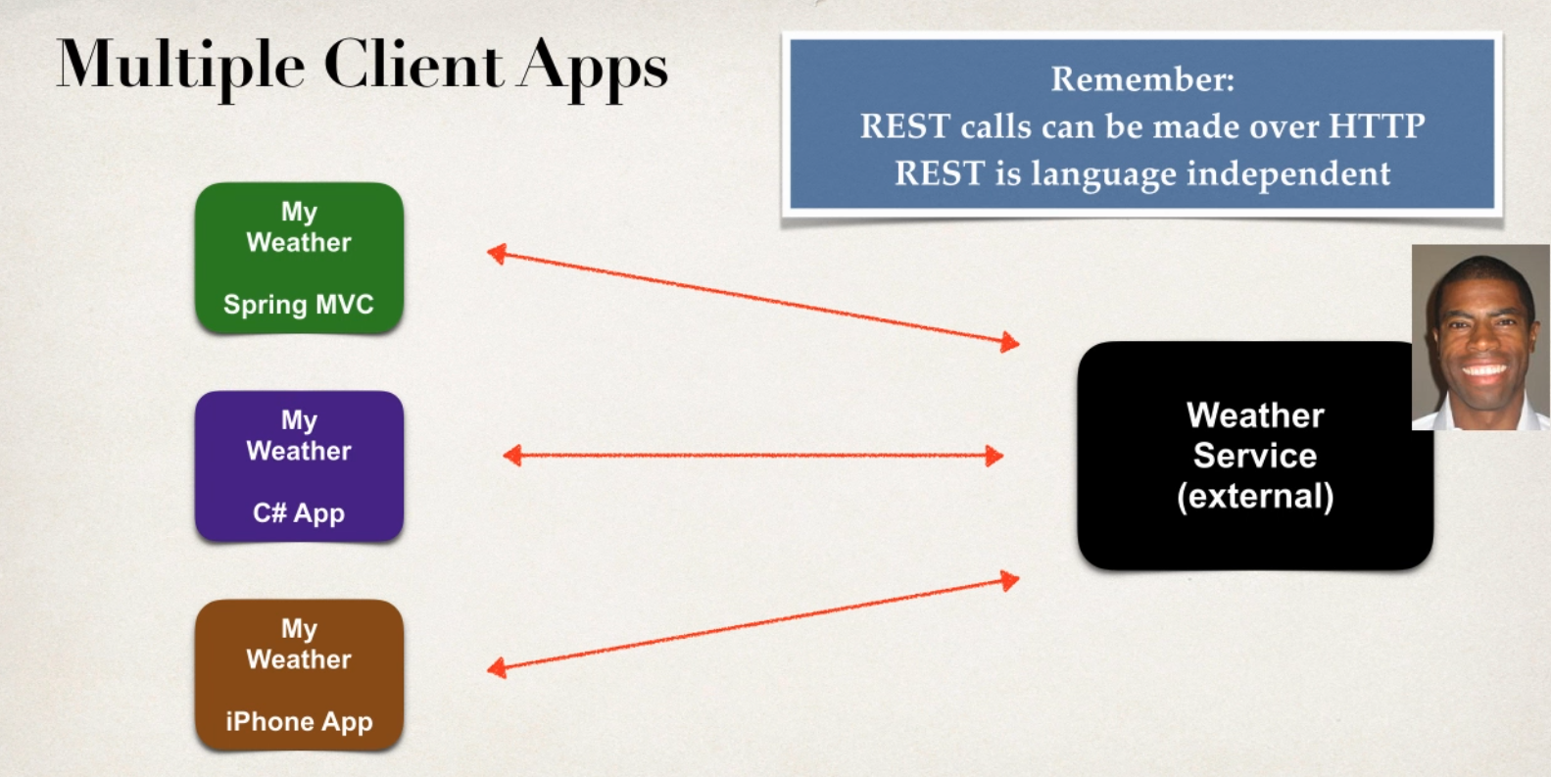

Simlar Apps like currney converter app

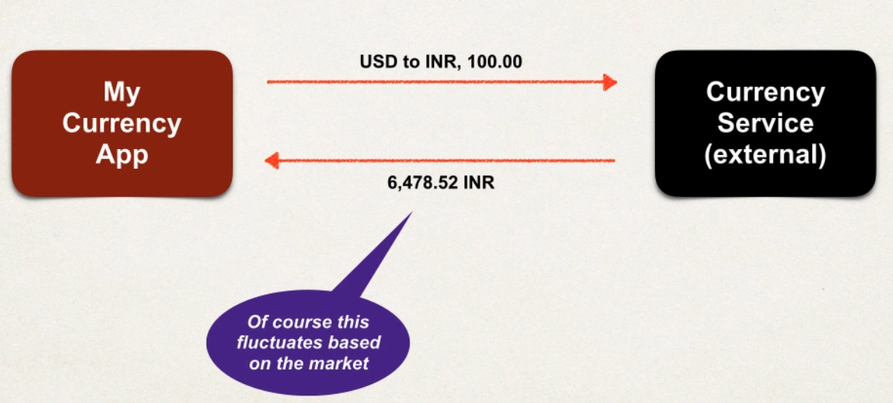



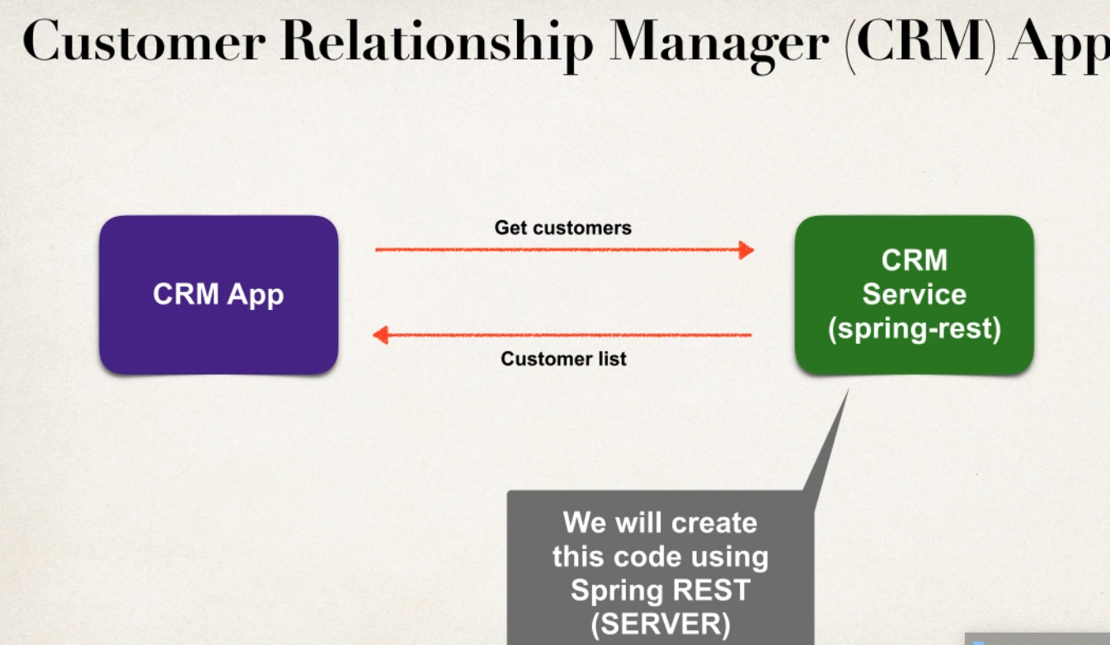

Ex Saleforce Platform API



JSON OVERVIEW

BASICS

-JAVA script Object Notation

-Light weight dat format for storing and exchanging data plain text

-lang independent.. not just only for java script can be used with any prog lang

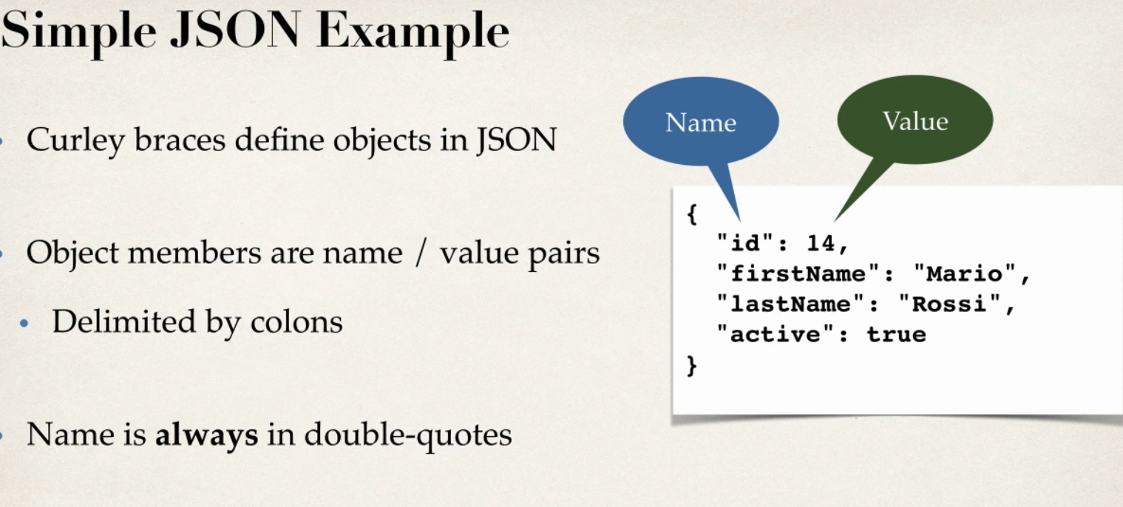

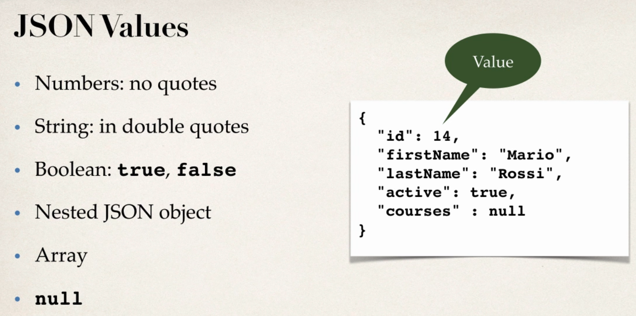

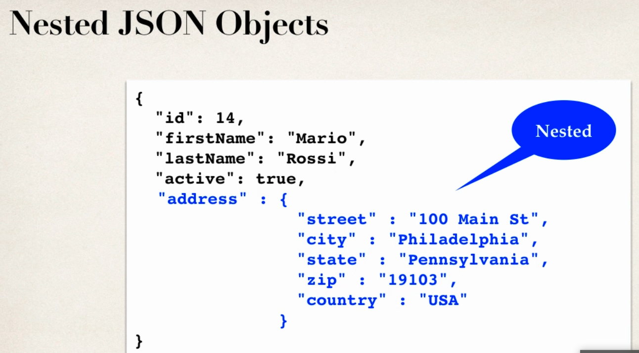

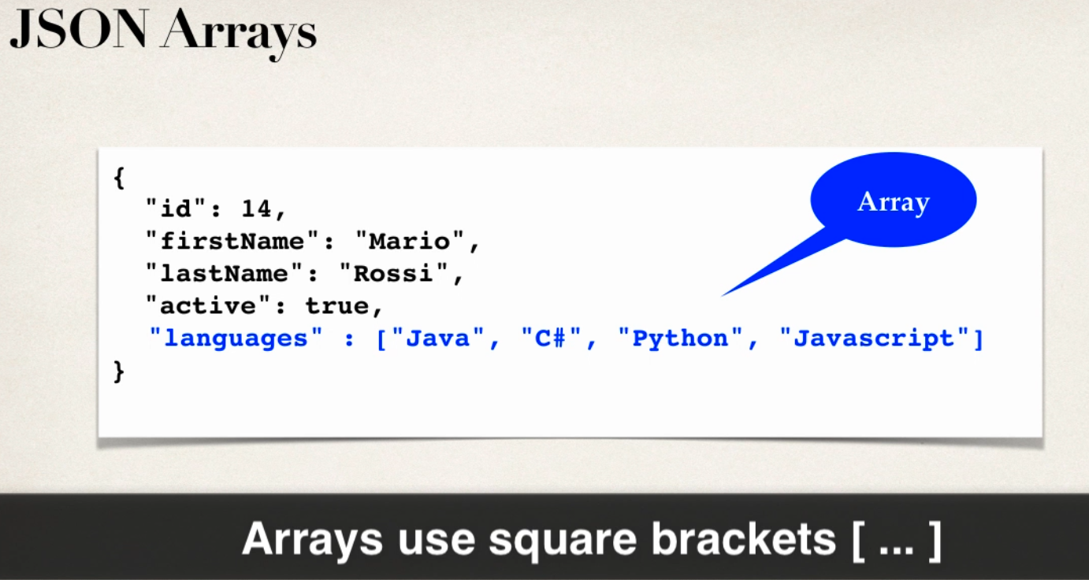

JAVA JSON DATA BINDING

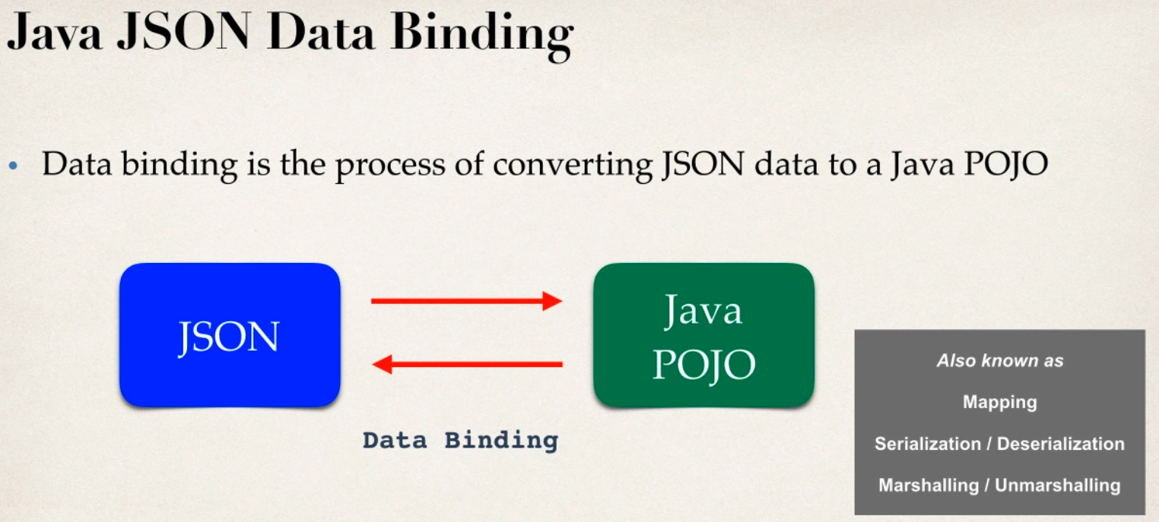

JSON data binding with jackson

- spring uses jackson project behind scene

- jackson handle data binding between json and java pojo

- jackson is separate project



JACKSON DATA BINDING

- jackson data binding API

Pkg: com.fasterxml.jackson.databind

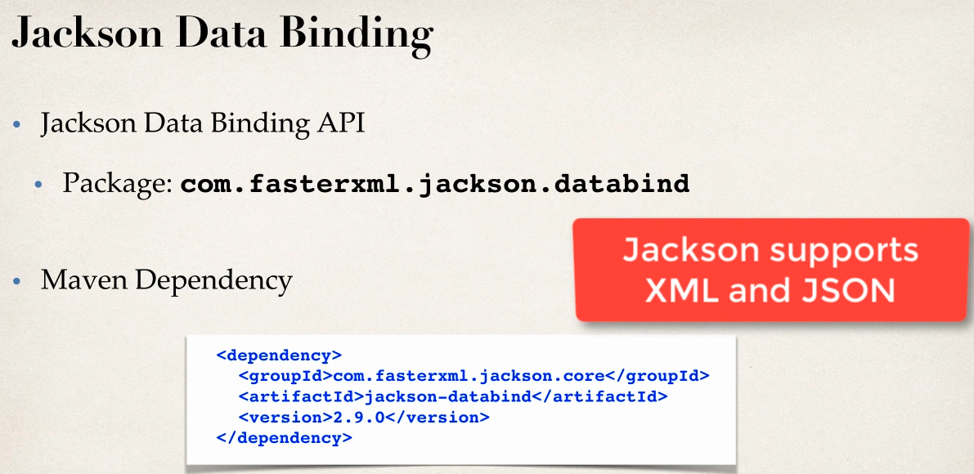

- by default jackson will call appropricate getter and setter method

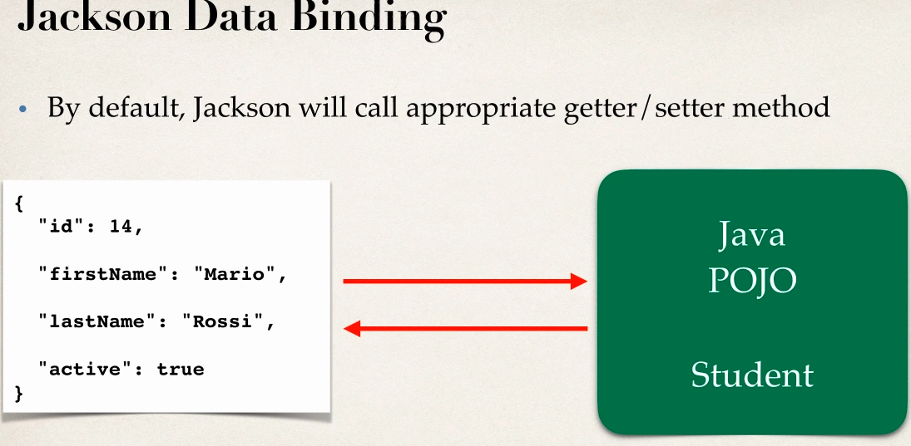

JSON TO JAVA POJO

- convert json to java pojo call settter methods on POJO

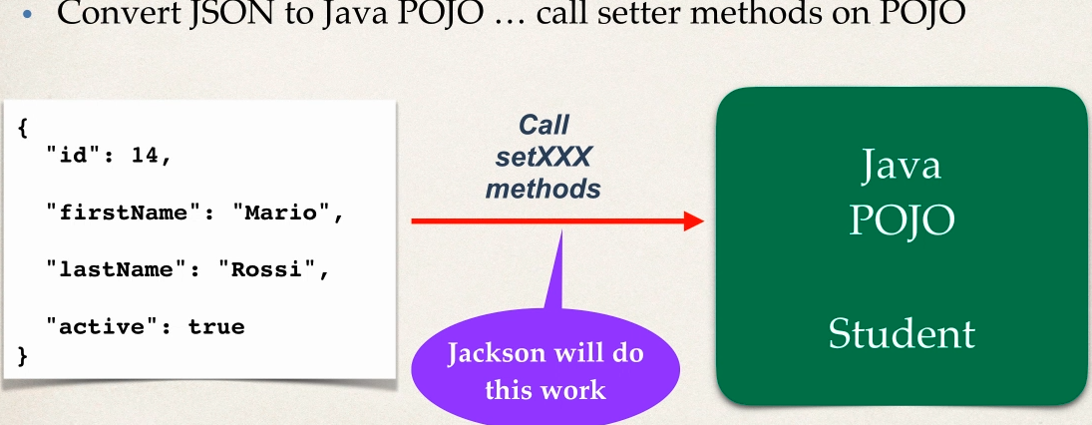

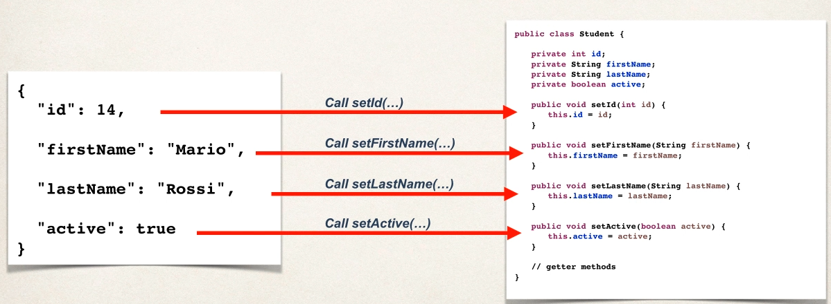

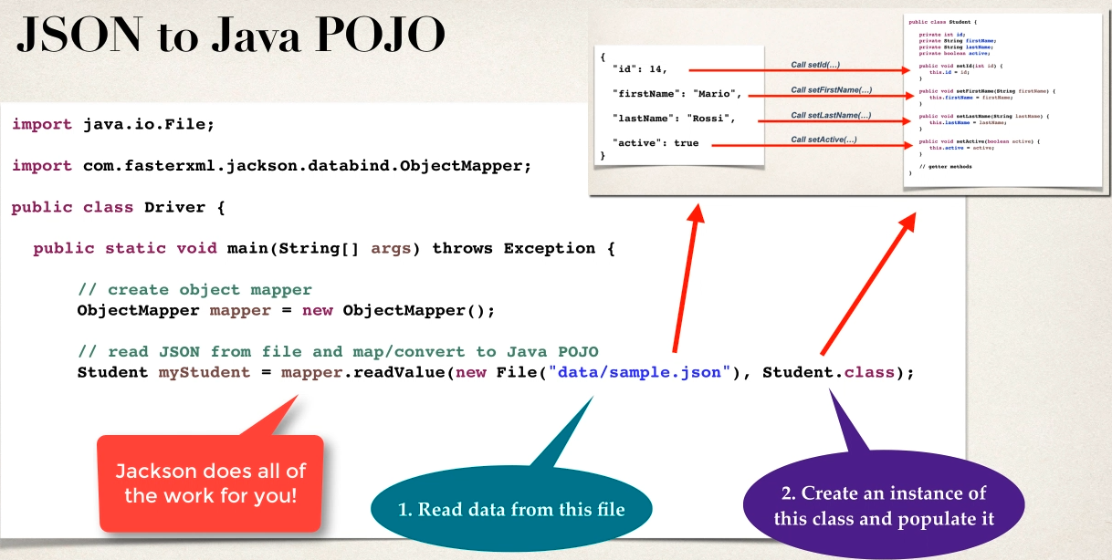

JAVA POJO TO JSON

-convert java pojo to json call getter methods on pojo

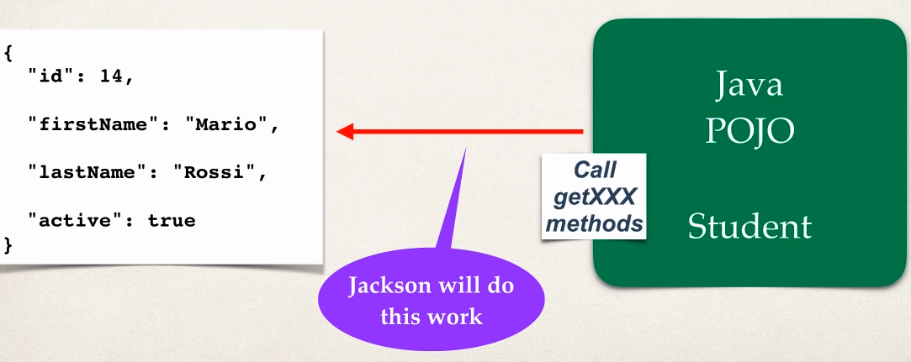

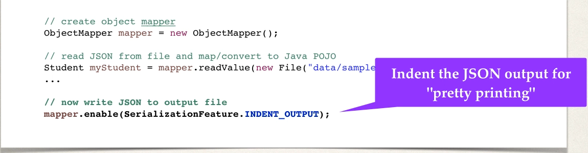

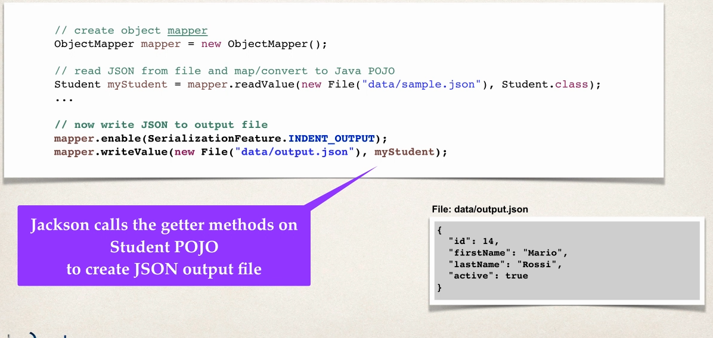

SPRING and JACKSON support

- in Spring REST appplications

- spirng will automatically handle jackson integration

- json data binding passed to REST controller is coneverted to pojo

- java object being returned from REST controller is converted to json usgin JACKSON

- all handled in backgrounf automatically

Converting JSON to JAVA POJO

Development Process

1 download and import starter files

2 add maven dependnecy for jackson project

3 create Student POJO class

4 create main driver app

Step 2

<!-- https://mvnrepository.com/artifact/com.fasterxml.jackson.core/jackson-databind -->

<dependency>

<groupId>com.fasterxml.jackson.core</groupId>

<artifactId>jackson-databind</artifactId>

<version>2.10.3</version>

</dependency>

Step 3

public class Student {

private int id;

private String firstName;

private String lastName;

private boolean active;

}

Step 4

public class DriverMainApp {

public static void main(String[] args) {

try

{

// create Object mapper

ObjectMapper mapper=new ObjectMapper();

// read json file and map/convert to java POJO :data/sample-lite.json

//Student student=mapper.readValue(new File("data/sample-lite.json"), Student.class);

Student student=mapper.readValue(new File("data/sample-full.json"), Student.class);

// print data of pojo

System.err.println("First Name ==>>"+student.getFirstName());

System.err.println("Last Name ==>>"+student.getLastName());

}

catch (Exception e) {

e.printStackTrace();

}

}

simple-lite.json

{

"id":14,

"firstName":***"sachin"***,

"lastName":***"gowda"***,

"active":true

}

WORKS with simple student entity

With simple-full.json

{

"id":14,

"firstName":***"sachin"***,

"lastName":***"gowda"***,

"active":true,

"address": {

"street":***"seeghali main road"***,

"city":***"Bangalore"***,

"state":***"karnataka"***,

"zip":***"573201"***,

"country":***"india"***

},

"languages":[***"English"***,***"Hindi"***,***"kannada"***]

}

Check this will get eception for above json since there is no setters for address and jackson always looks for setter method whos key in json file

com.fasterxml.jackson.databind.exc.UnrecognizedPropertyException: Unrecognized field "address" (class com.spring.restjacson.SpringRestJacksonDemo.Student), not marked as ignorable (4 known properties: "lastName", "id", "active", "firstName"])

Solution create a Nested class Address since it is an json object in json object

Address Entity

public class Address {

private String street;

private String city;

private String state;

private String zip;

private String country;

}

MAIN APP

Student student=mapper.readValue(new File("data/sample-full.json"), Student.class);

// print data of pojo of Student class

System.err.println("First Name ==>>"+student.getFirstName());

System.err.println("Last Name ==>>"+student.getLastName());

// print data of pojo of Address class

System.err.println("City Name ==>>"+student.getAddress().getCity());

System.err.println("State Name ==>>"+student.getAddress().getState());

// print data of pojo of Student class

System.err.println("Languages ==>>"+Arrays.toString(student.getLanguages()));

-IF JSON HAS property you dnt care about wouldnt be great to ignore it

USE CASE

- new proprty added to json our code is not aware of it so it will cause exception

-modify code to ignore properties

- add one more property in json file dnt add in java entity

-add this below line will ignore the proerty and Exception will be avoided

@JsonIgnoreProperties(ignoreUnknown=true)

public class Student

REST HTTP Basics

- most common use of REST is over HTTP

- leverage HTTP methods for CRUD operations

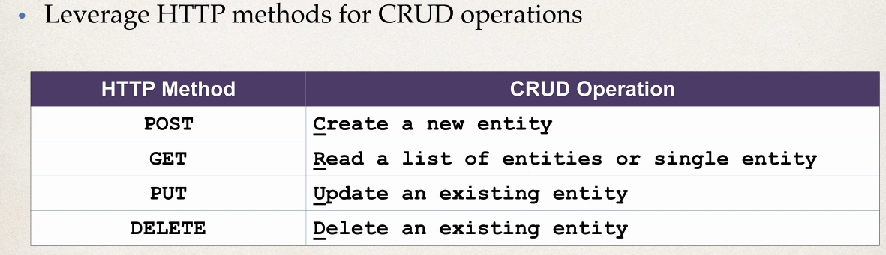

HTTP Messages

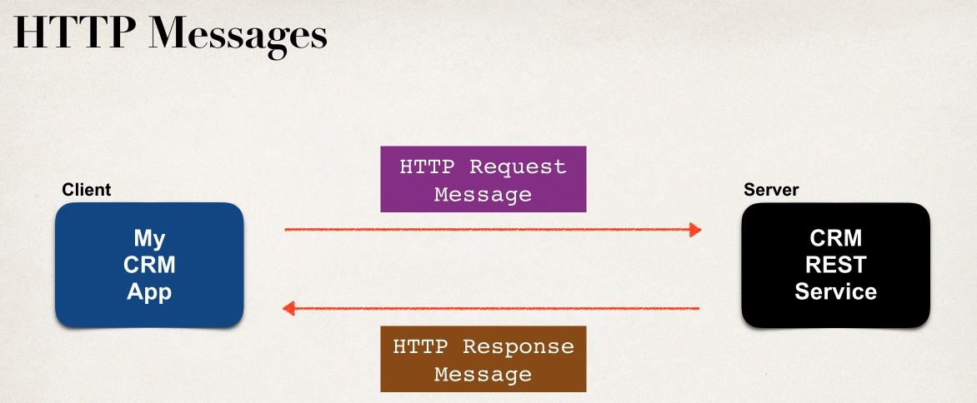

HTTP Request Message

1 Request Line: the http command GET,POST,PUT,DELETE

2 Header Variables: request metadata

3Message Body : contents of message/payload like entity will be in the msg body as json

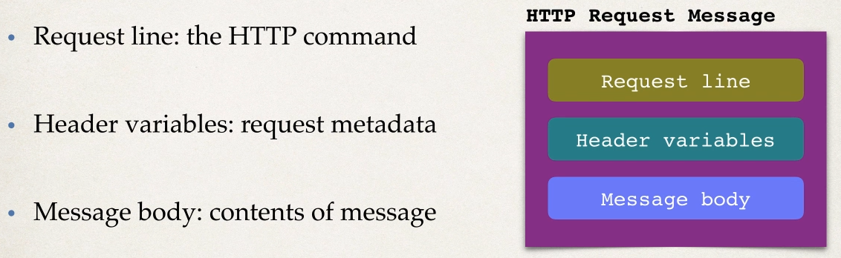

HTTP Response Message

1 Response Line : server protocol and status code like ststus code like http status code :200,500,404

2 Header variables : repsponse metadata

3 message body : contents of message body like xml or json

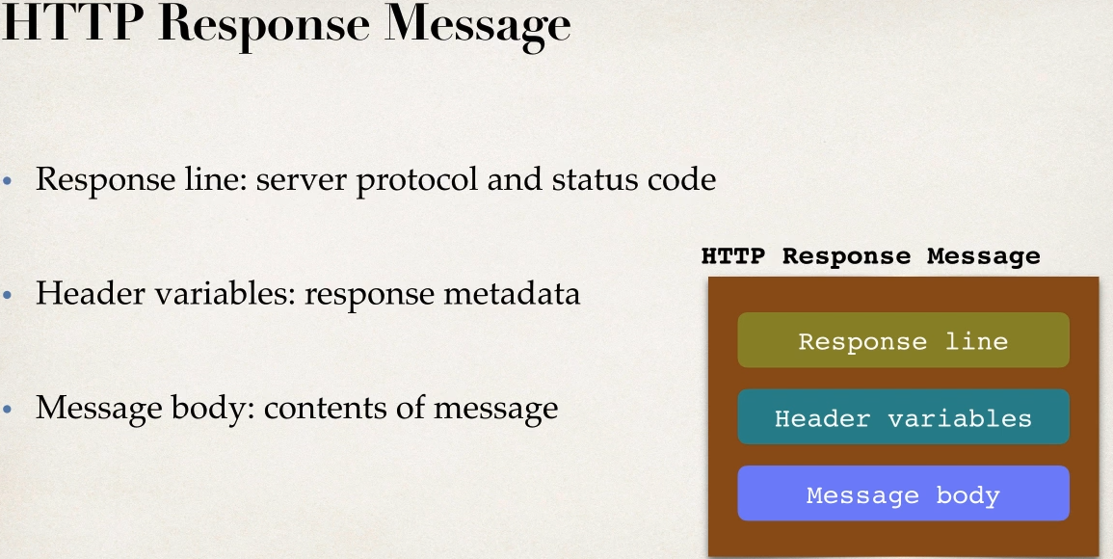

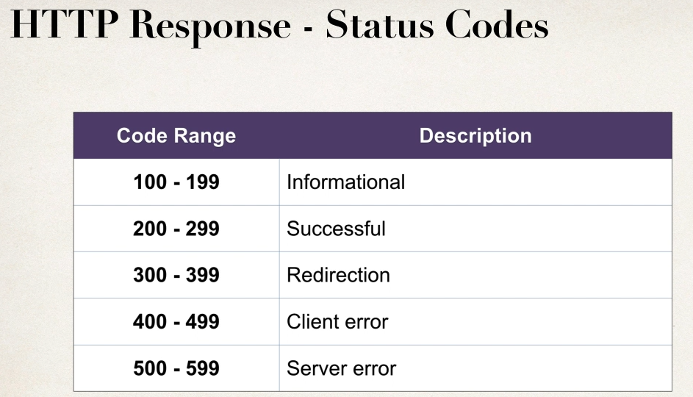

MIME Content Types

-message format is described by MIME content type

-Multipurpose Internet Mail-Extension

Syntax

Basic : type/sub-type

Example

text/html,text/plain

application/json,application/xml

Client Tool

To send HTTP request to the WEB service /API

Tools like curl,postman

Use this to chck online test REST API

Use it with postman

<http://www.jsontest.com/>

-provides a collections of backend REST services to test against

Ex call

1 API to get IP

http reg : <http://ip.jsontest.com/>

Response : {"ip": "106.206.15.16"}

2 API for Date

<http://date.jsontest.com/>

{

"date": "04-23-2020",

"milliseconds_since_epoch": 1587632213288,

"time": "08:56:53 AM"

}

Fake Online REST API for Testing and Prototyping

<http://jsonplaceholder.typicode.com/>

Try API like

<http://jsonplaceholder.typicode.com/users>

SPRING REST Controller

-spring MVC provide support for Spring REST

-new Annontaion @RestController

-Extension of @Controller

-Handles REST request and response

-Spring REST will also automatically convert java pojo to json

- as long as we have jackson project in project

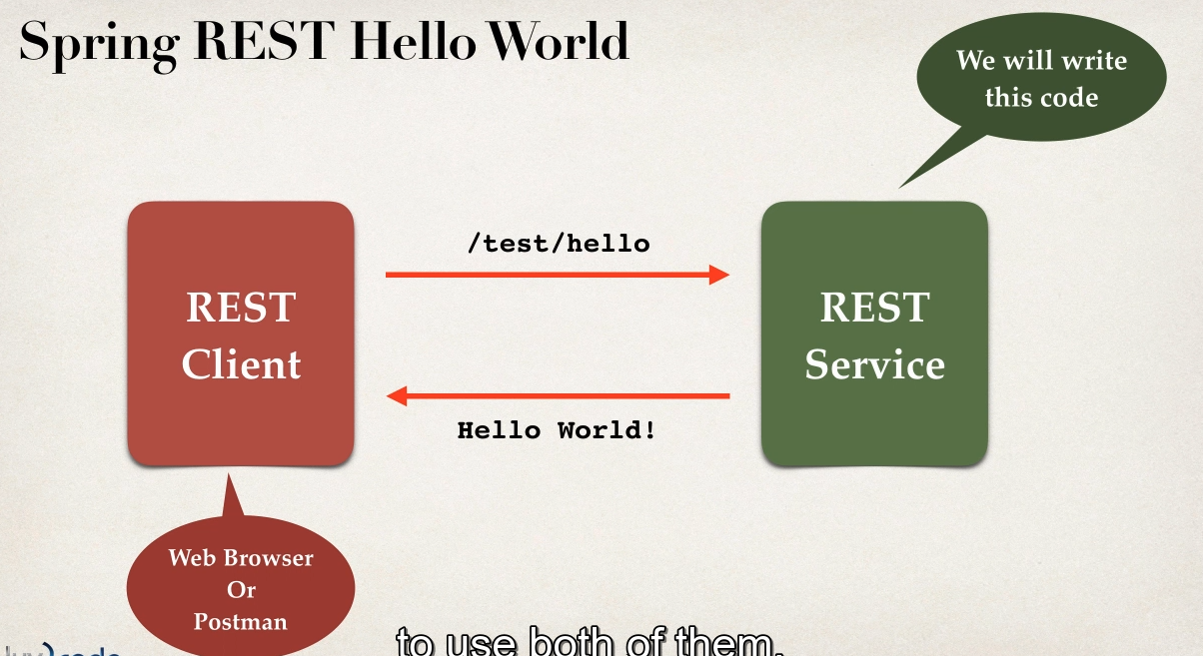

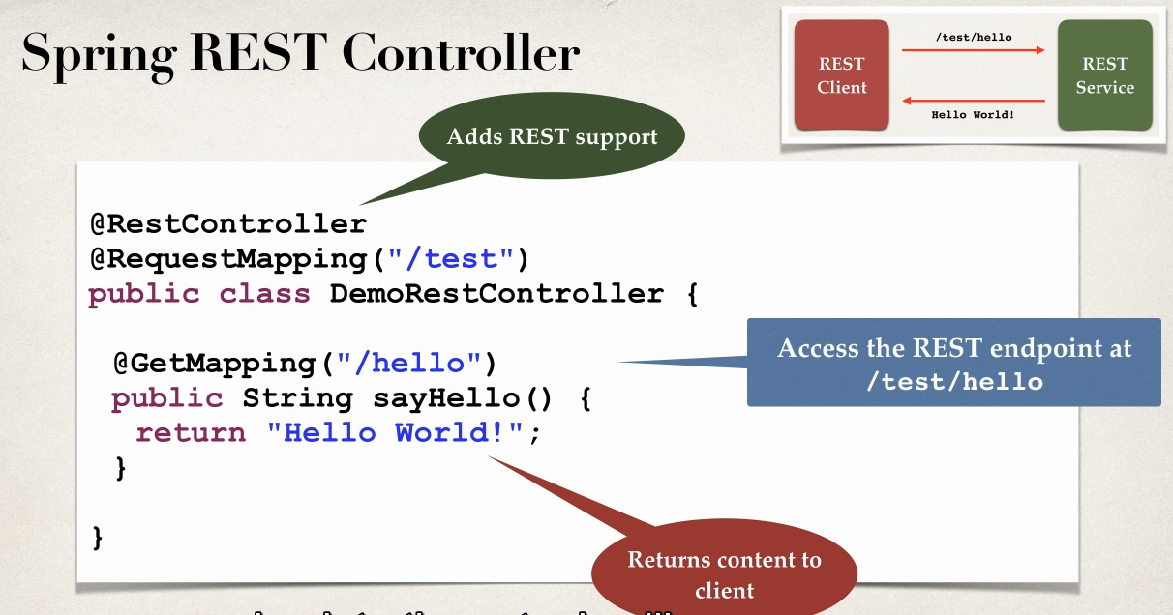

WEB BROWSER VS POSTMAN

-for simple Simple REST testing for GET req

-web browser and postman are similar

- For advanced REST testing PSOT,PUT etc POSTMAN will be much support

-posting json data ,setting content type

-passing HTTP req headers,authentication etc

Development Process

1 add maven dependency for Spring MVC and JACKSON

2 Add code for all Java COnfig : @Configuration

3 Add code for all JAva config : Servlet Intializer

4 create Spring REST service using @RestController

Spring REST API STUDENT Class

- return list of students

GET

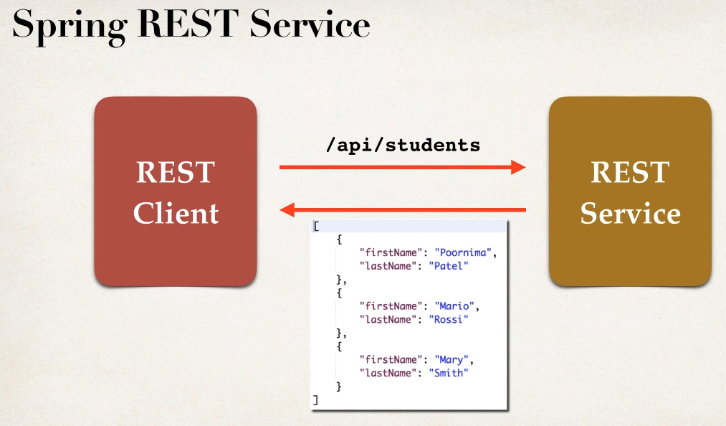

Convert POJO JAVA to JSON

-REST will retrun List<Student>

- need to convert List<Student> to JSON

- jackson will handle

Spring and Jackson support

-spring will handle jackson integration

-JSON data being passed to REST controller is converted to JAVA POJO

-JAva POJO being returned from REST controller is converted into JSON

1 Create Class

Student

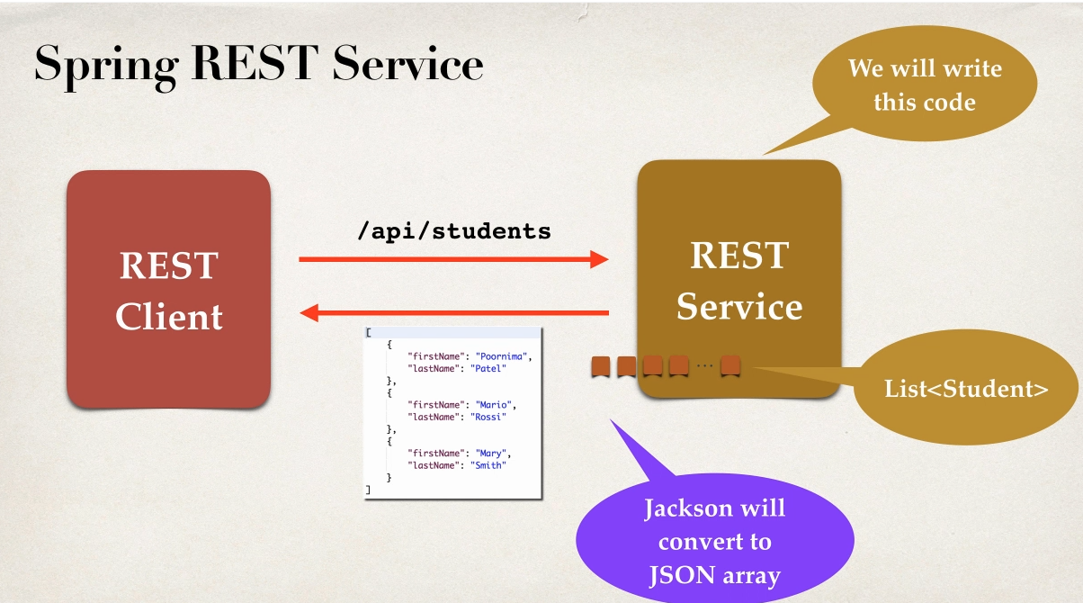

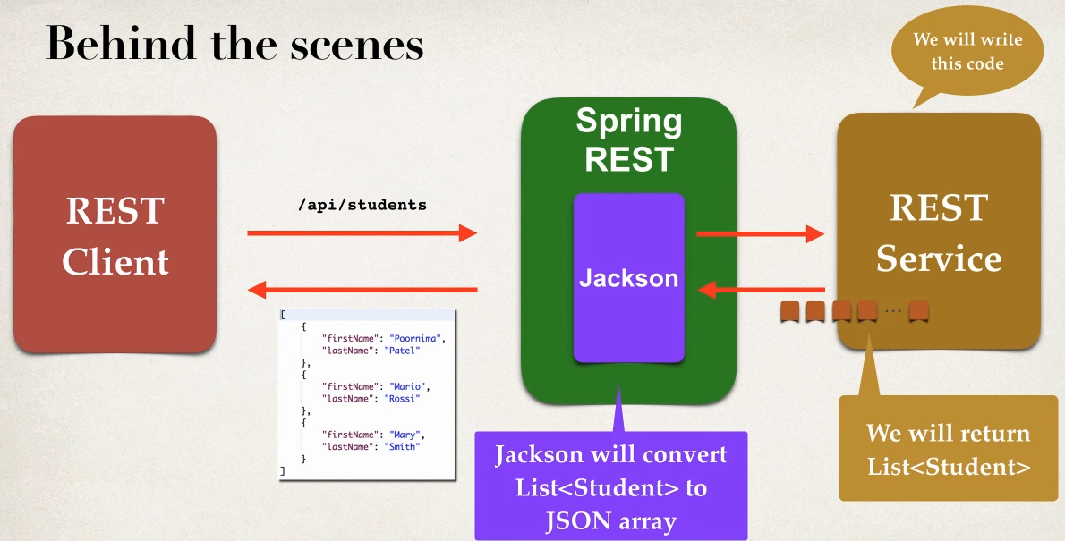

Development Process

1 create Java POJO class Student

2 Create Spring REST service using @RestController

public class Student {

private String firstName;

private String lastName;

public Student() {

}

public Student(String firstName, String lastName) {

super();

this.firstName = firstName;

this.lastName = lastName;

}}

@RestController

@RequestMapping("/api")

public class StudentDemoController {

//define end point for /students return list of student

@GetMapping("/students")

public List<Student> getStudents()

{

List<Student> students=new ArrayList<>();

students.add(new Student("sachin", "gowda"));

students.add(new Student("darshan", "gowda"));

students.add(new Student("manasa", "gowda"));

return students;

}

}

Use ?in end of URL to avoid cached data from browser. It will give real time data if its taking cache data

<http://localhost:7777/SpringRestAPIDemo/api/students?>

Spring REST with PATH Variable

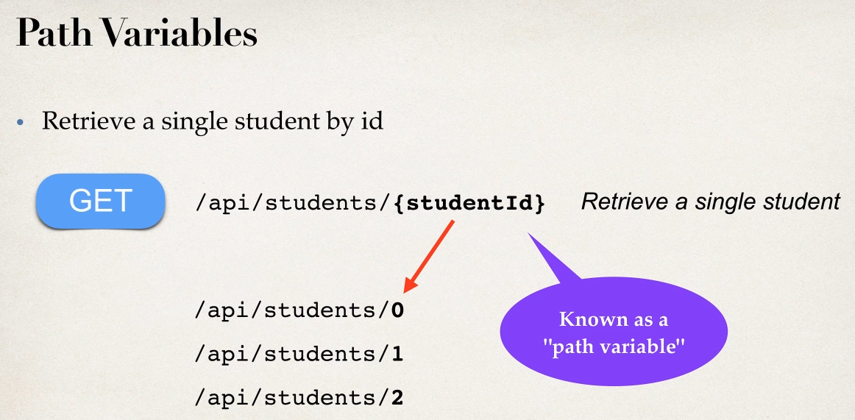

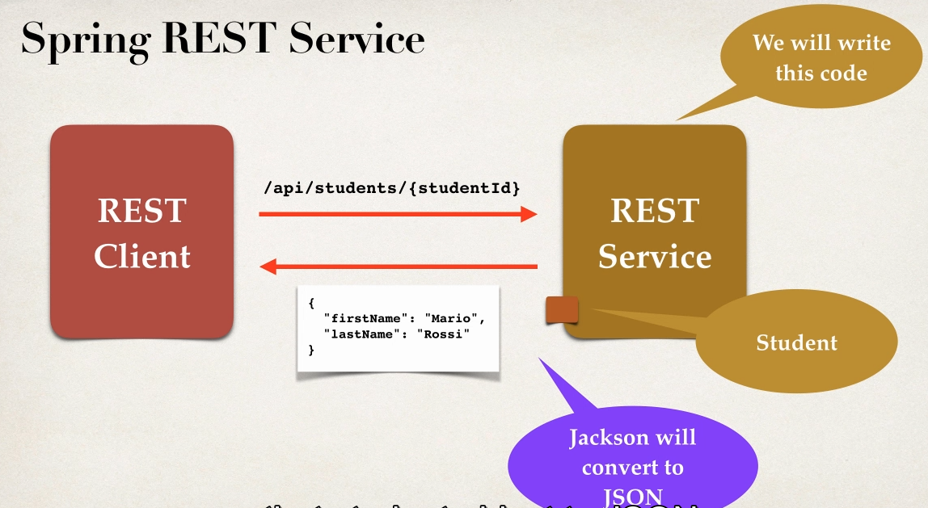

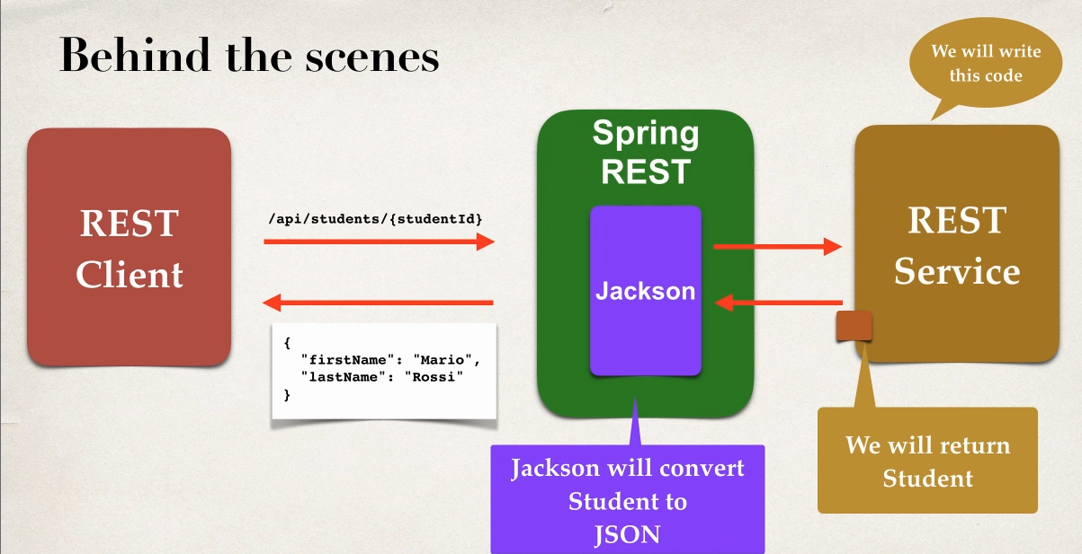

Development Process

1 Add Request mapping to Spring REST Service

Bind path variable to method parameter using @pathvariable

Step 1

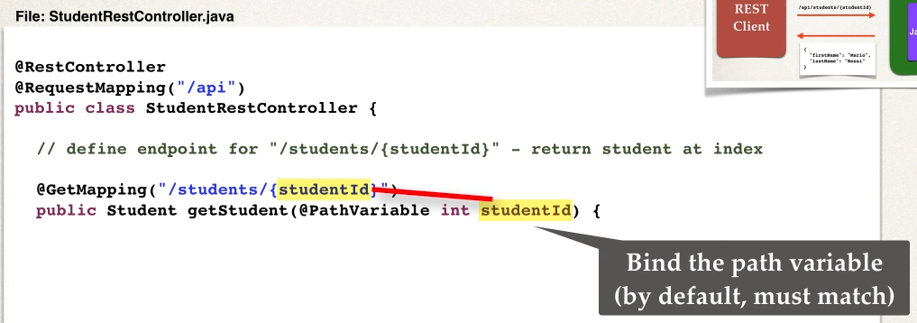

@RestController

@RequestMapping("/api")

public class StudentDemoController {

private List<Student> students;

// Define @PostConstructor to load the Student data only once

@PostConstruct

public void loadData()

{

students=new ArrayList<>();

students.add(new Student("sachin", "gowda"));

students.add(new Student("darshan", "gowda"));

students.add(new Student("manasa", "gowda"));

}

//define end point for /students return list of student

@GetMapping("/students")

public List<Student> getStudents()

{

// data is alredy been lodaed bcz of @PostConstruct

return students;

}

// define end point for /students/{studentId} retrun student at index

@GetMapping("/student/{studentId}")

public Student getStudent(@PathVariable int studentId)

{

// by default variable should match

// data is alredy been lodaed bcz of @PostConstruct

return students.get(studentId);

}

}

Result of using PATH VARIABLE

<http://localhost:7777/SpringRestAPIDemo/api/student/1> data in index 1

<http://localhost:7777/SpringRestAPIDemo/api/student/9> will give error 500 response since array out of bound

Spring REST Exception HANDLING

- we don’t want show error of html as a response so need to handle

-handle the exception retrun error in JSON

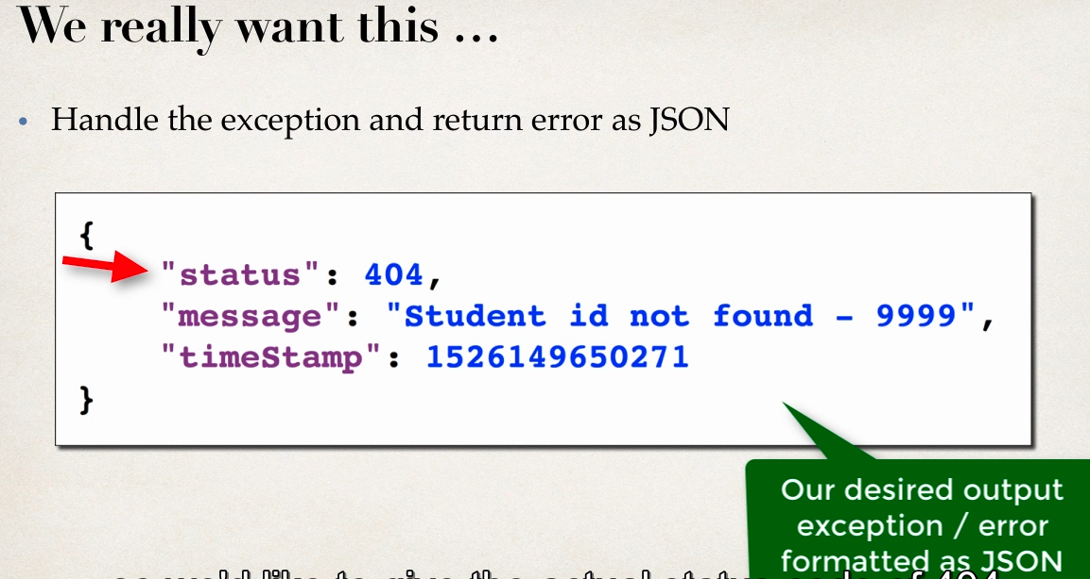

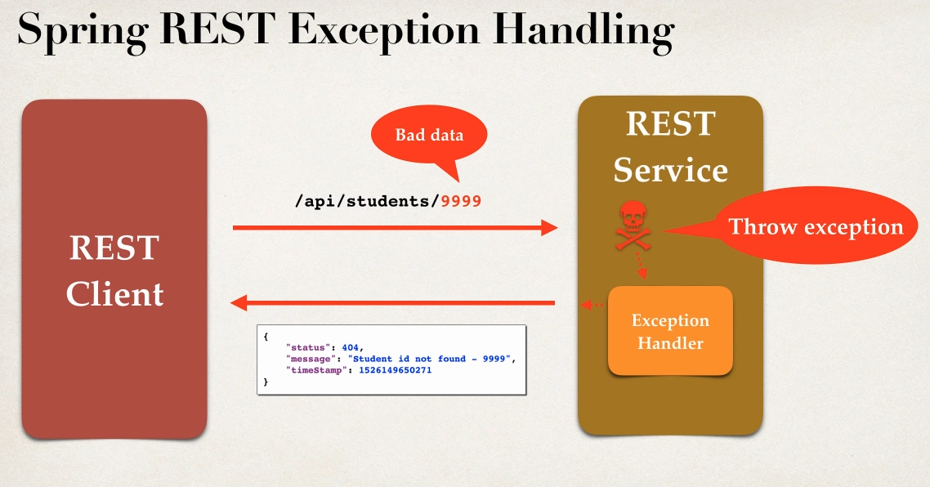

Development Process

1 create custome error response code

2 create custom exception class

3 update the REST service to through exception if student not found

4 Add exceptional Handler Method using @ExceptionHnadler

Step 1

-Create Custom error response class

-custom error response wil be sent back to cleint as json

- will define as java class (POJO)

-jackson will handle converting it so json

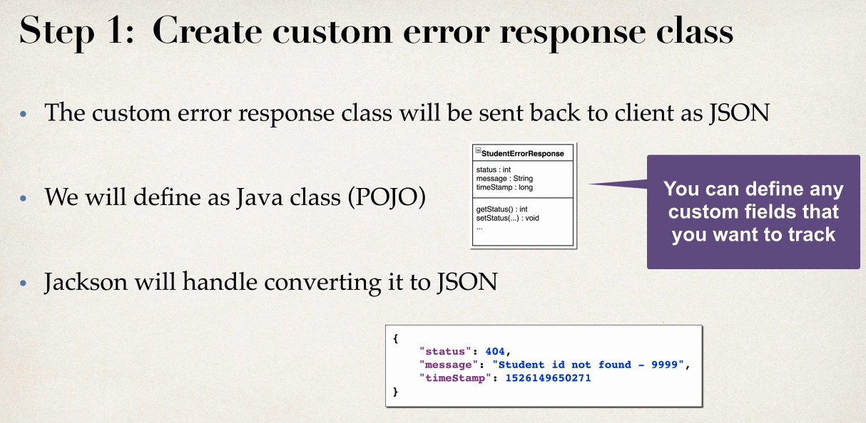

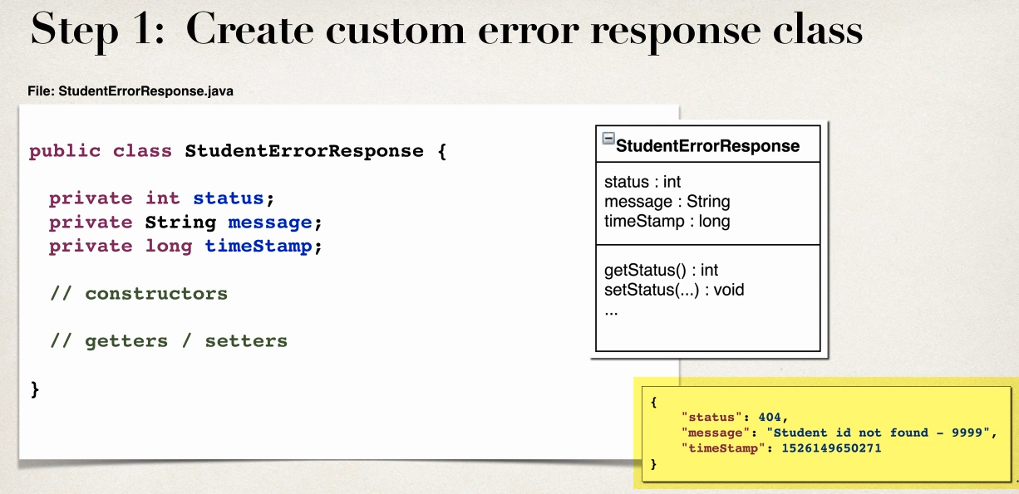

public class StudentErrorResponse {

private int status;

private String message;

private long timeStamp;

public StudentErrorResponse() {

}

public StudentErrorResponse(int status, String message, long timeStamp) {

this.status = status;

this.message = message;

this.timeStamp = timeStamp;

}

}

Step 2 create custom student Exception

- the custom student exception will used by our REST service

- in code if student cant be find then we’ll throw exceptions

- need to define custom Student exception class

-StudentNotFoundException

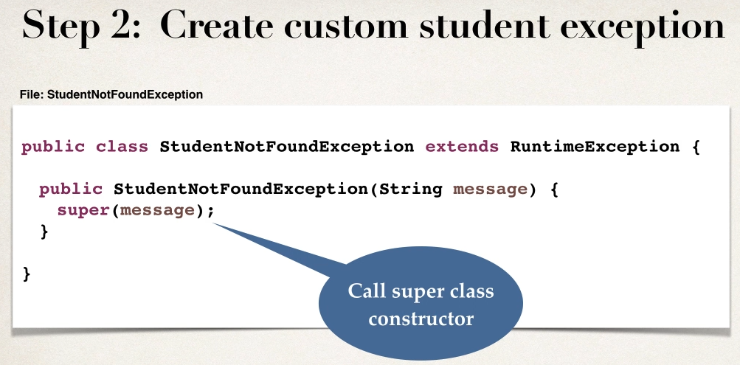

public class StudentNotFoundException extends RuntimeException {

public StudentNotFoundException(String message, Throwable cause) {

super(message, cause);

}

public StudentNotFoundException(String message) {

super(message);

}

public StudentNotFoundException(Throwable cause) {

super(cause);

}

}

Step 3

Update REST service to throw Exception

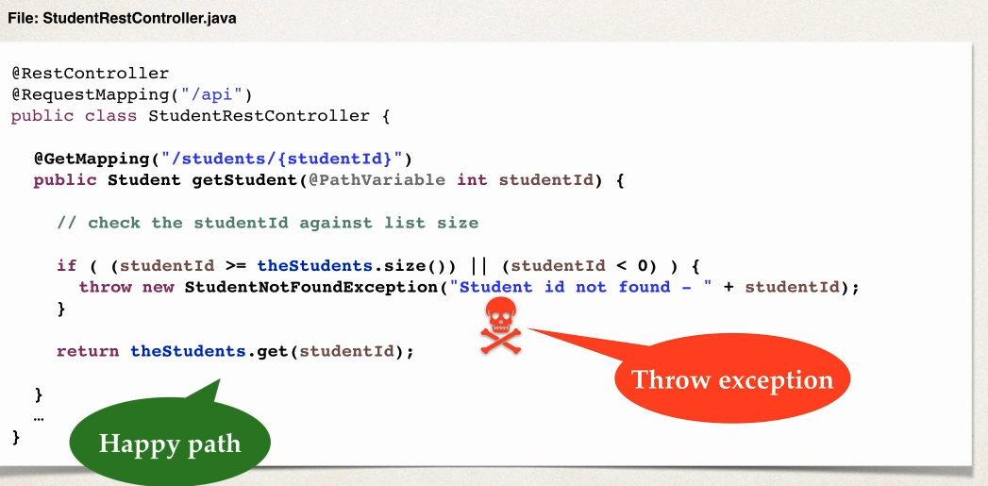

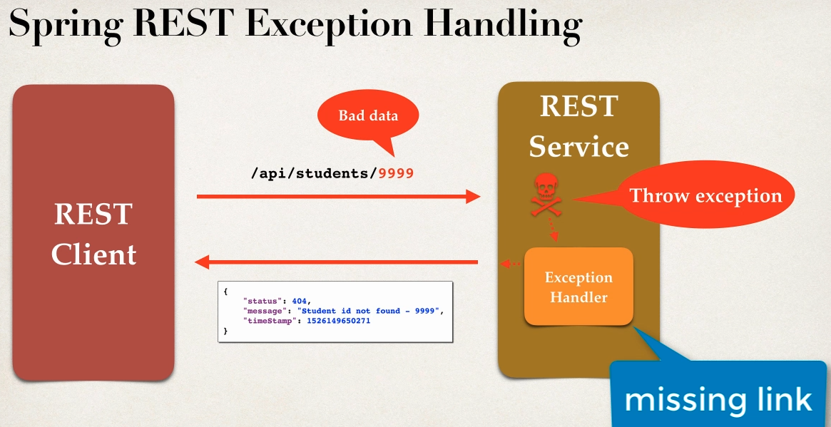

Missing link will step 4

Step 4: Add exception handler method

1 Define Exception Handler Method with @ExceptionHandler

2 Exception will return ResponseEntity

3 ResponseEntity is a wrapper for the HTTP response object

4 ResponseEntity provides fine-gained controll to specify -> HTTP status code,HTTP headers and Response Body

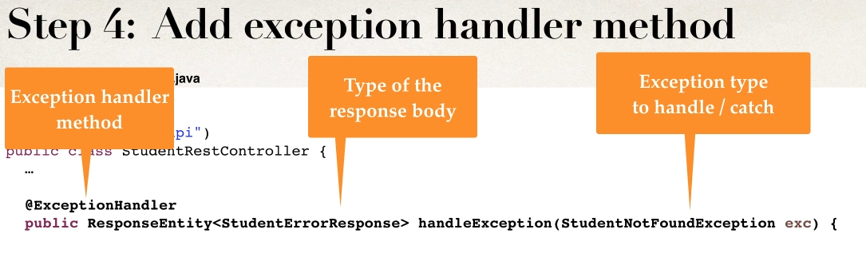

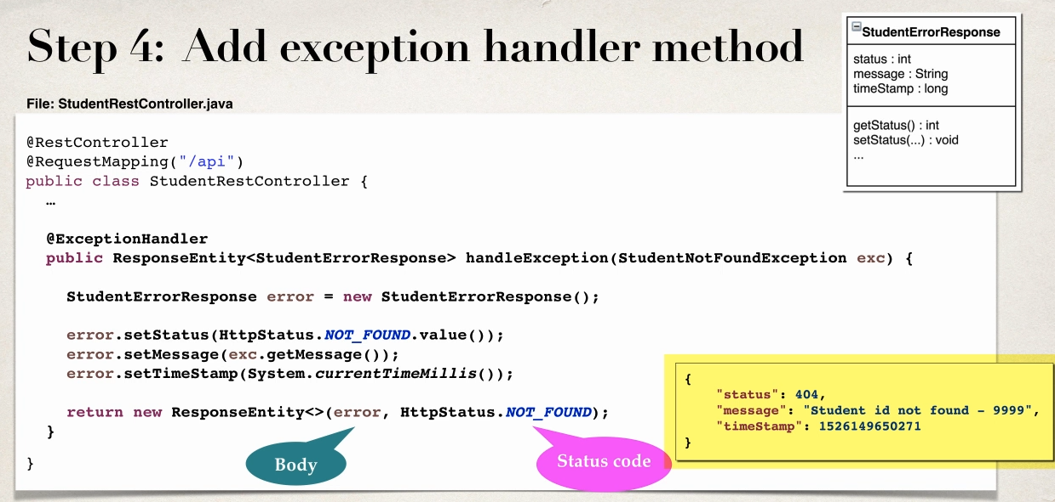

// define end point for /students/{studentId} retrun student at index along with custom Exception handling

@GetMapping("/student/data/{studentId}")

public Student getStudentData(@PathVariable int studentId)

{

// check student against list size

if(studentId>=students.size() || studentId<0)

{

throw new StudentNotFoundException("Student Id not Found- "+studentId);

}

return students.get(studentId);

}

// Add Exception handler using @ExceptionHandler

@ExceptionHandler

public ResponseEntity<StudentErrorResponse> handleException(StudentNotFoundException exe)

{

// create a StudentErrorResponse

StudentErrorResponse error=new StudentErrorResponse();

error.setStatus(HttpStatus.NOT_FOUND.value());

error.setMessage(exe.getMessage());

error.setTimeStamp(System.currentTimeMillis());

//return ResponseEntity

return new ResponseEntity<>(error,HttpStatus.NOT_FOUND);

}

<http://localhost:7777/SpringRestAPIDemo/api/student/data/-9>

This works for number data if we send string as a parameter

Will get 400 exception initaly we are getting 404 to handle 400

Modify Code to handle Generation Exception

// add another exception handler to catch any exception(catch ALL)

@ExceptionHandler

public ResponseEntity<StudentErrorResponse> genericExceptionHandling(Exception exe)

{

// create a StudentErrorResponse

StudentErrorResponse error=new StudentErrorResponse();

error.setStatus(HttpStatus.BAD_REQUEST.value());

error.setMessage(exe.getMessage());

error.setTimeStamp(System.currentTimeMillis());

//return ResponseEntity

return new ResponseEntity<>(error,HttpStatus.BAD_REQUEST);

}

Spring REST -GLOBAL EXCEPTION HANDLING

-Exception handler codes is only for the specfic REST controller

-cnt be resused by other controllers

- for large project we need Global exception handlers

-promotes reuse

-centralized exception handling

Spring @ControllerAdvice

- it is similar to interceptor /filter

- pre process request to controllers

-post process response to handle exceptions

-perfect for Global Exception

- Actuly Real time use AOP

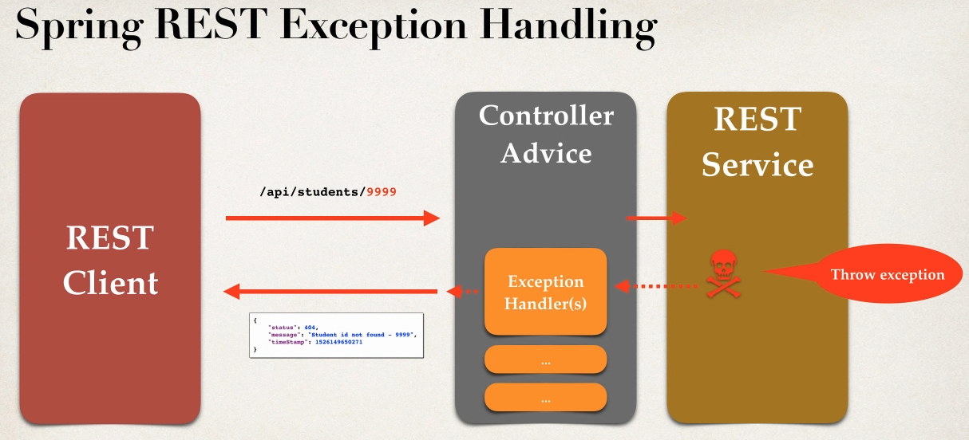

Development Process

1 create new @ControllerAdvice

2 Refactor REST SErvice -- remove Exception handling Code

2 Add Exception Handling Code to @ControllerAdvice

BEST PRACTICE USE CASE

@ControllerAdvice

public class StudentRestExceptionHandler {

@ExceptionHandler

public ResponseEntity<StudentErrorResponse> handleException(StudentNotFoundException exe) {

// create a StudentErrorResponse

StudentErrorResponse error=new StudentErrorResponse();

error.setStatus(HttpStatus.NOT_FOUND.value());

error.setMessage(exe.getMessage());

error.setTimeStamp(System.currentTimeMillis());

//return ResponseEntity

return new ResponseEntity<>(error,HttpStatus.NOT_FOUND);

}

@ExceptionHandler

public ResponseEntity<StudentErrorResponse>

genericExceptionHandling(Exception exe) { // create a StudentErrorResponse

StudentErrorResponse error=new StudentErrorResponse();

error.setStatus(HttpStatus.BAD_REQUEST.value());

error.setMessage(exe.getMessage());

error.setTimeStamp(System.currentTimeMillis());

//return ResponseEntity

return new ResponseEntity<>(error,HttpStatus.BAD_REQUEST);

}

}

Spring API Design BEST Practice

-for realtime projects who will use API

-how they will use API

-design API based on reuirement

API Design Process

1 review the API requirements

2 Identify main resource and entity

3 use http methods to assiagn action on resources

Step 1

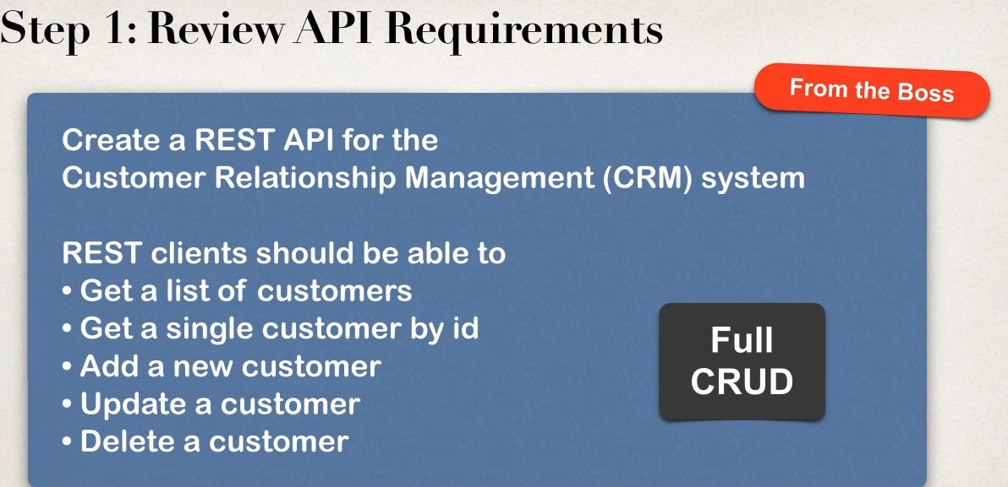

Step 2 :Identify main resources / entity look for the most prominent “noun”

-Crm project “customer”

-convention is to use plural form of entity/resources :customers

/api/customers

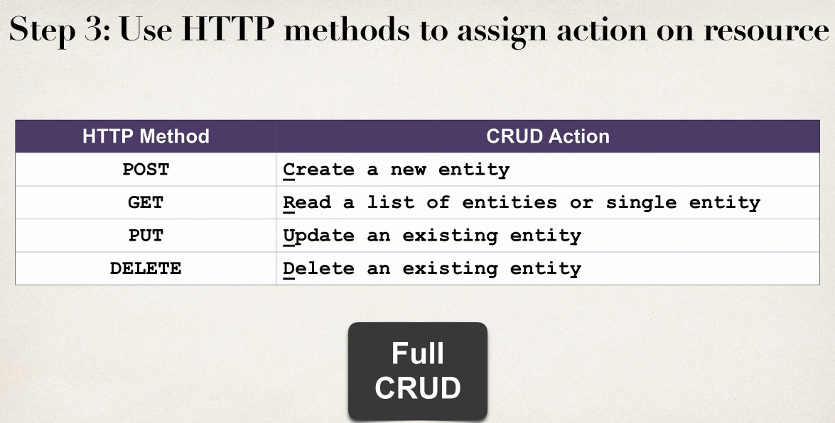

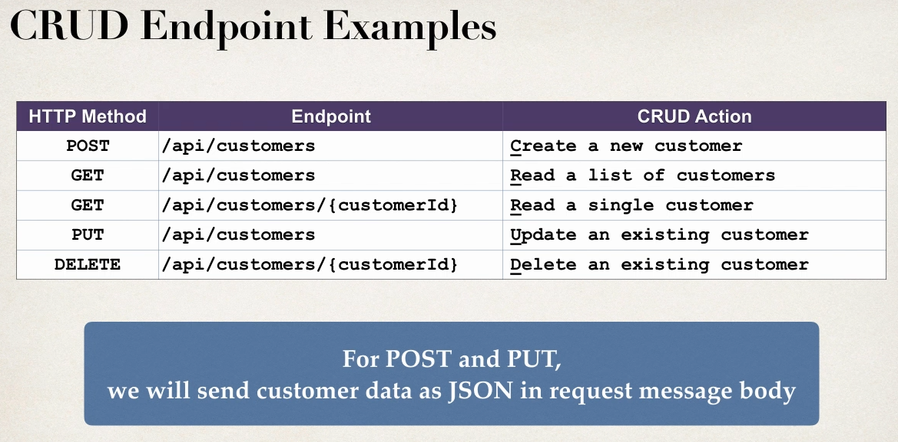

ANTI PAtterns

- dnt do this this are REST anti-patterns ,bad practice

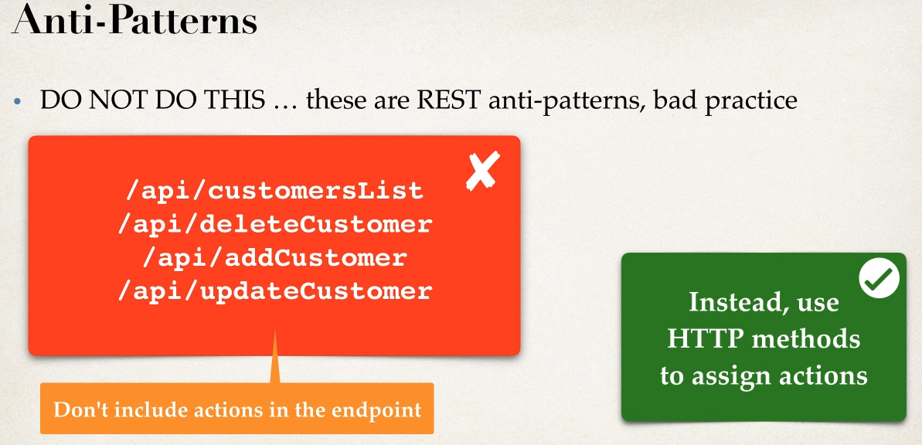

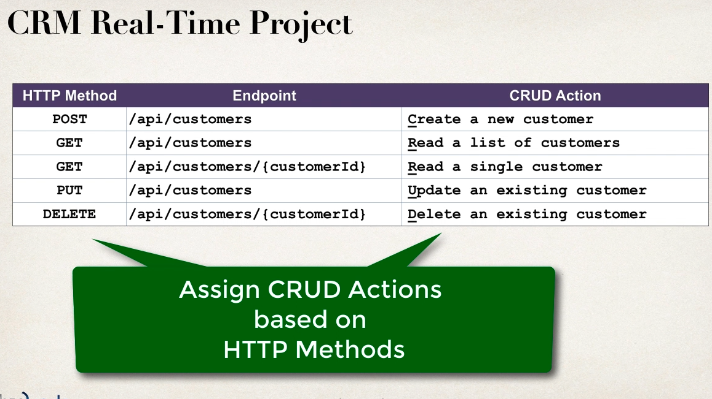

Some Real Time Project Smaple API’s

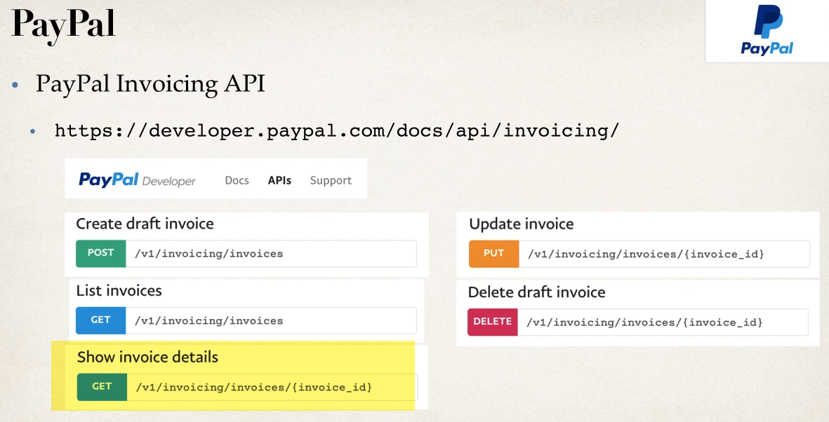

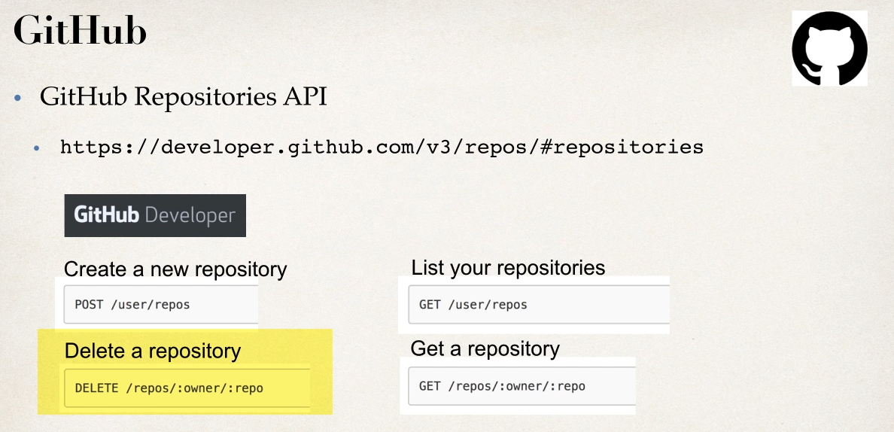

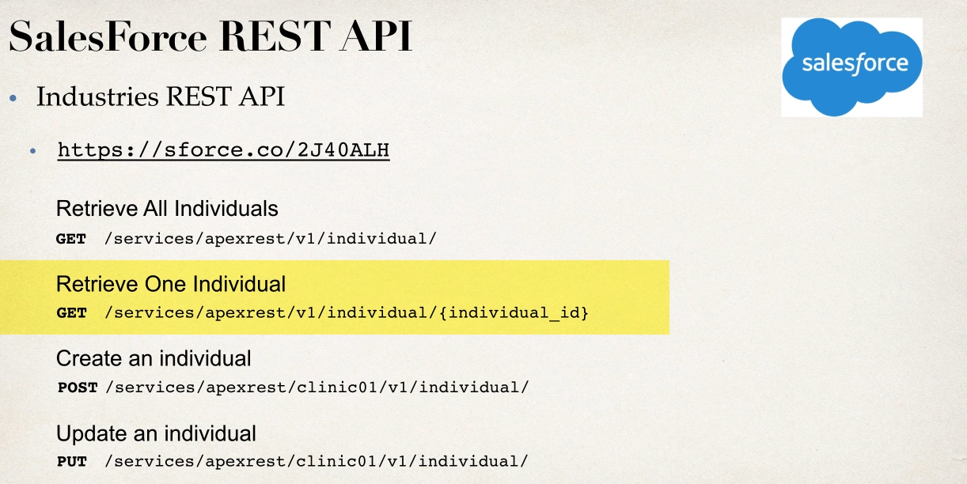

SPRING REST CRUD REAL TIME PROJECT

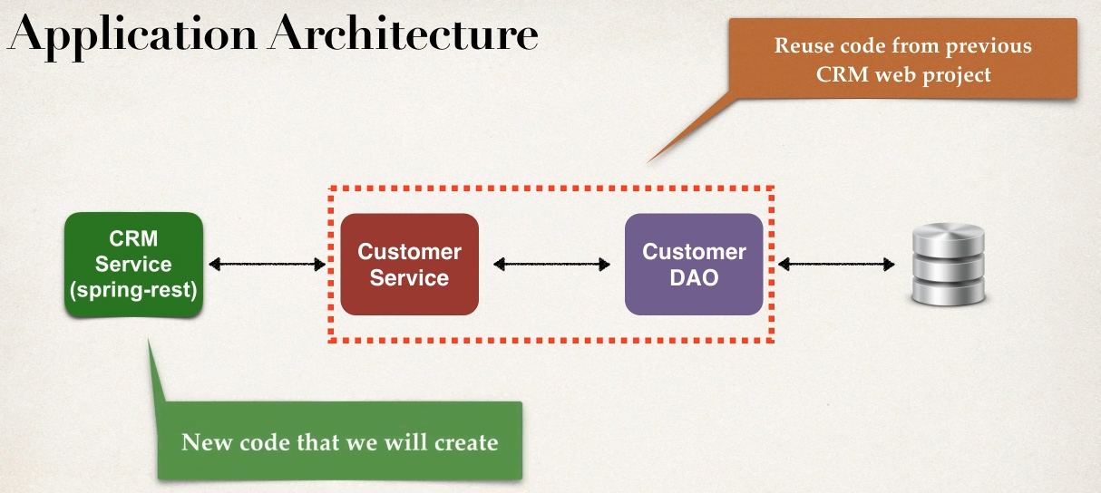

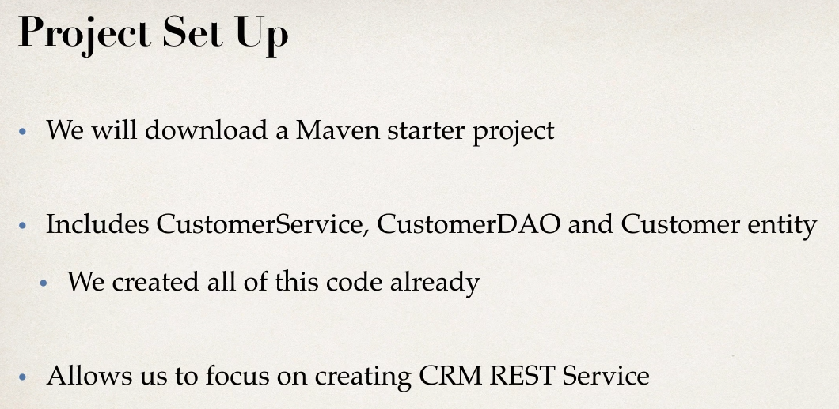

Development Process

1 Get customers

2 get Single customer by id

3 add new customer

4 Update existing customer

5 delete a customer

Code Review

1 pom.xml file

2 all java config

3 config file fr DBconnection

4 Hibernate Entity class:customer

5 DAO

6 Services

GET CONSUMERS

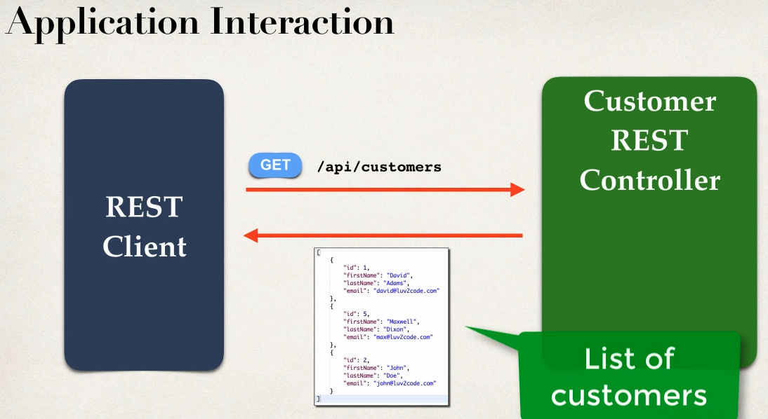

Development Process

1 create Customer REST controller

2 Autowire customer Services

3 Add mapping for GET /customers

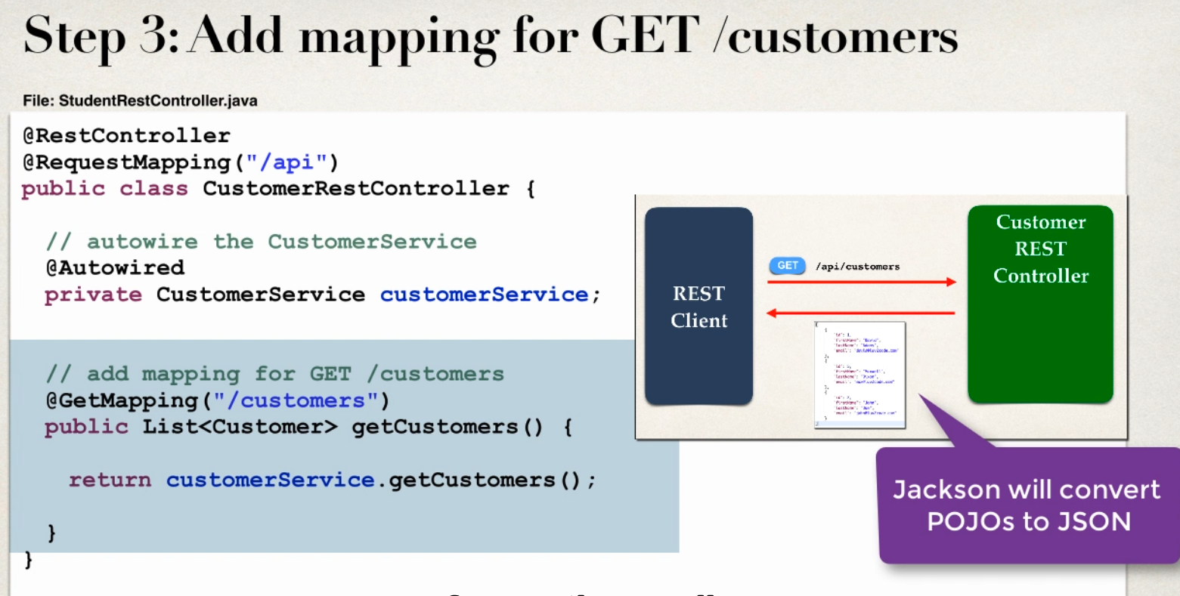

GET SINGLE RECORD from CUSTOMER based on ID

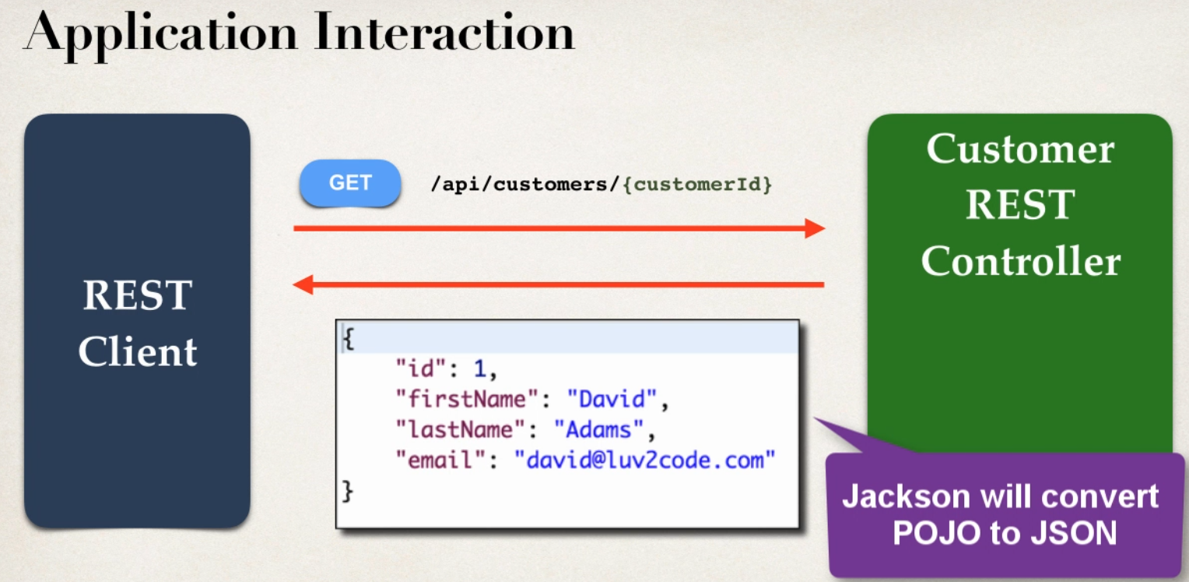

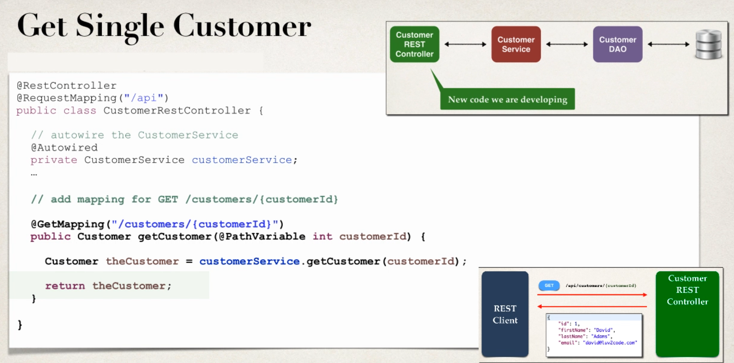

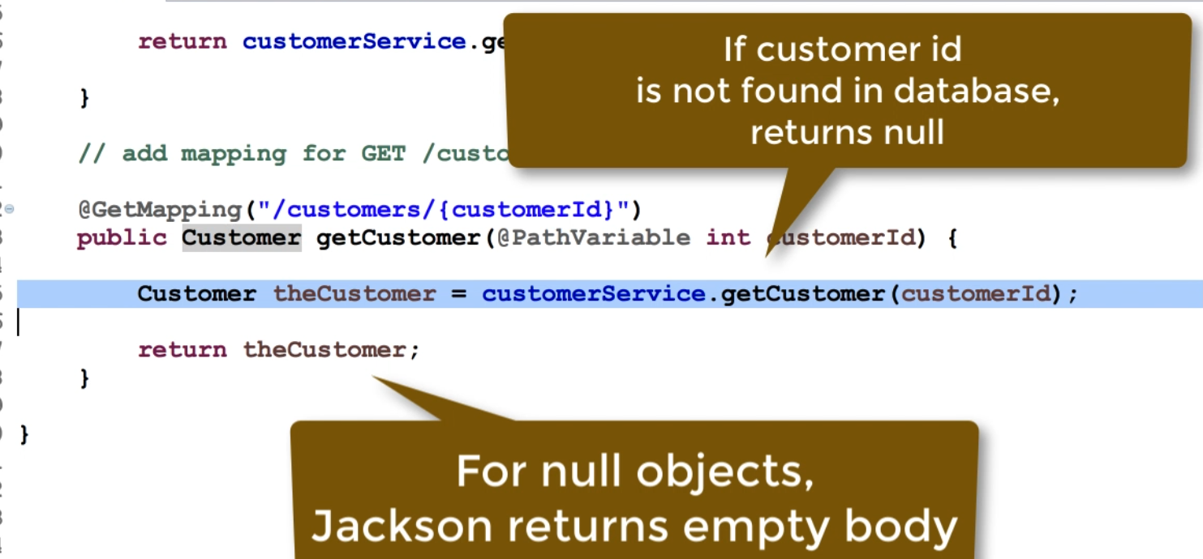

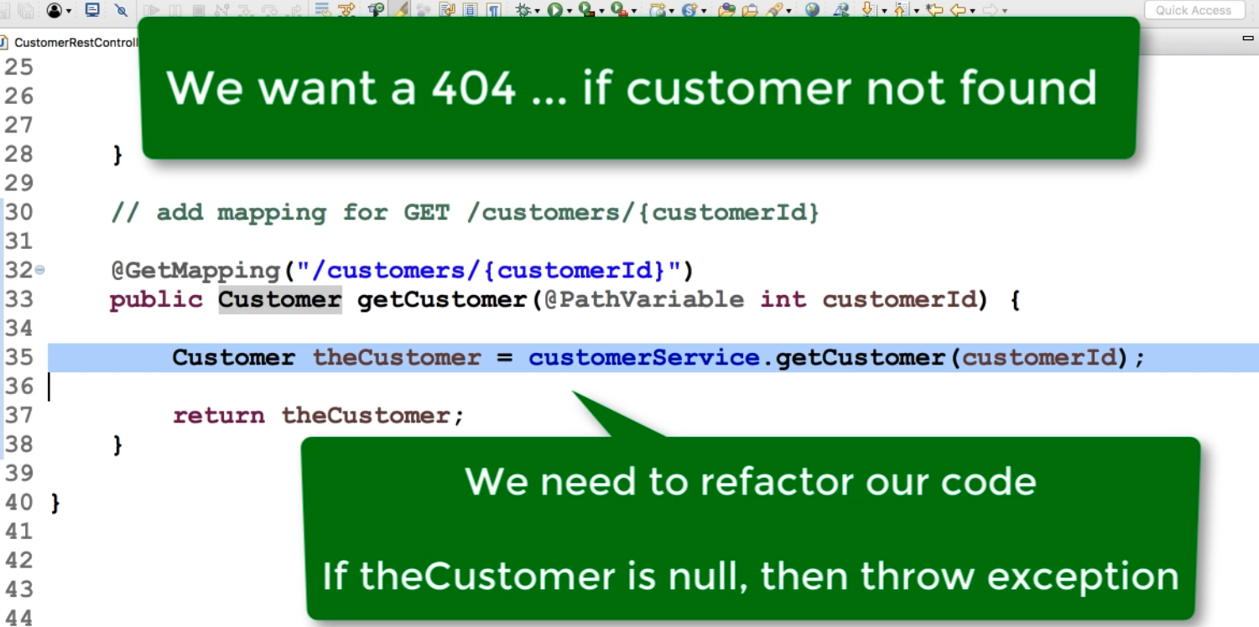

HANDLING CRM REST EXCEPTION HANDLING

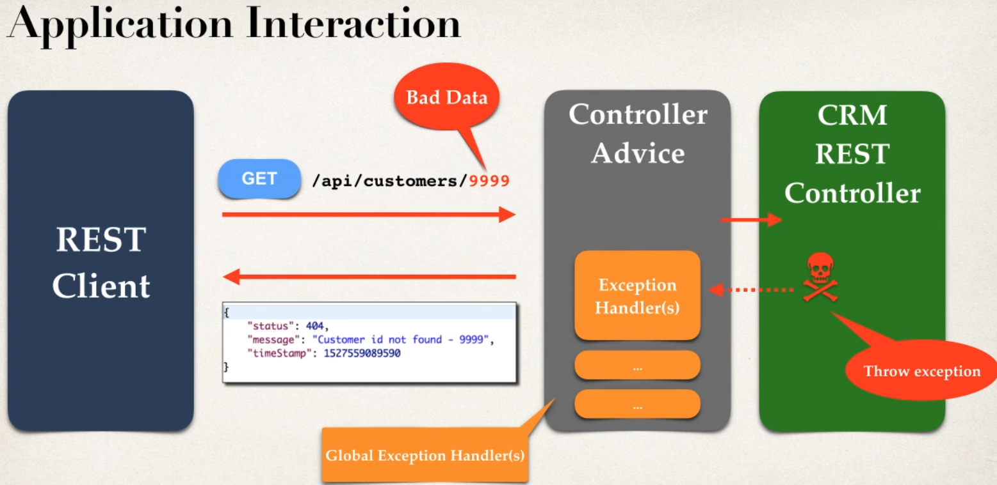

Development Process

1 create a custom error response class

2 create custom exception class

3 update REST service to thorow if customer not found

4 handle as Exception handler methods using @ExceptionHandler

Go thorugh Code

SPRING CRM ADD a CUSTOMER

Using POST http method

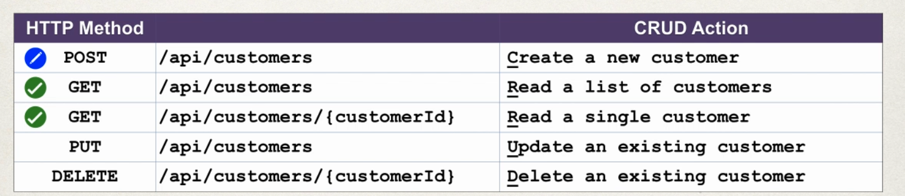

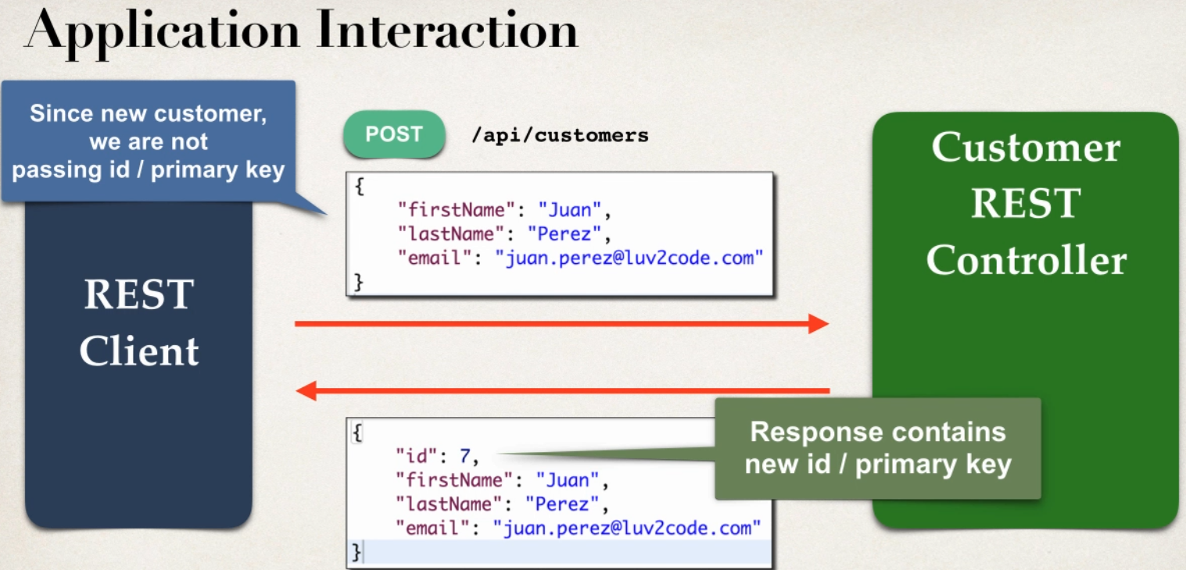

Access Request Body

- Jackson will convert Request body from JSON to POJO

- @RequestBody annotaion binds POJO to a method parameter

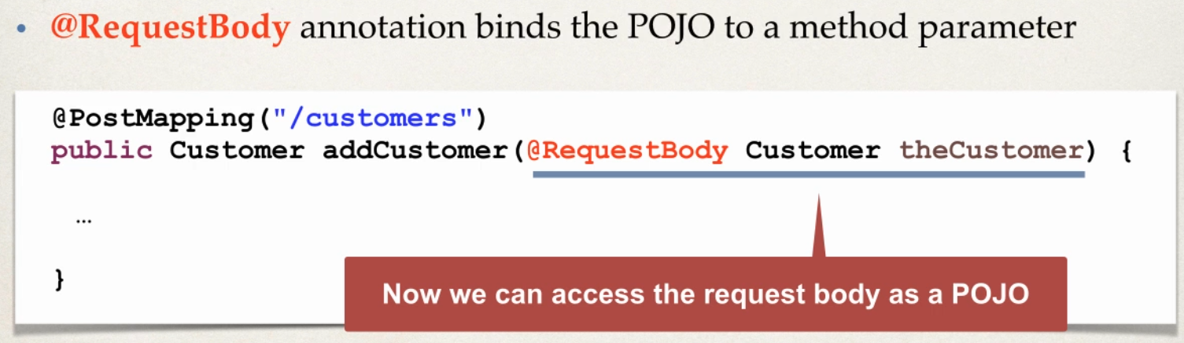

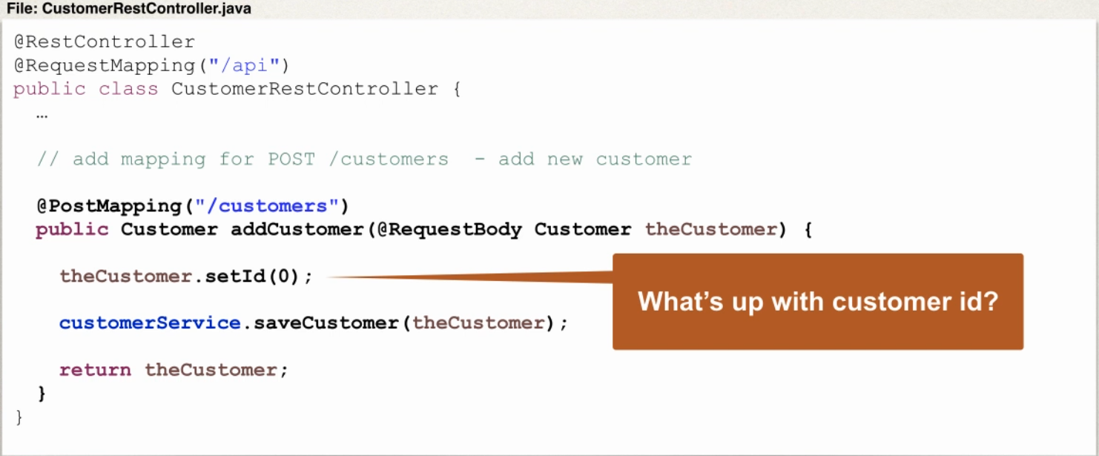

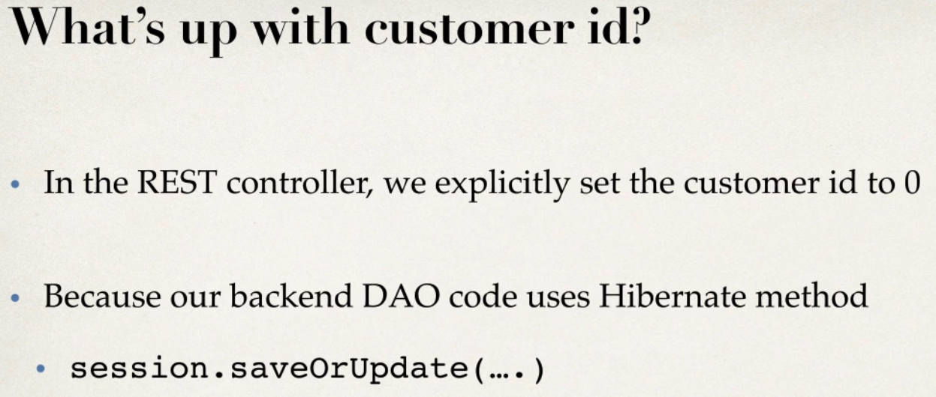

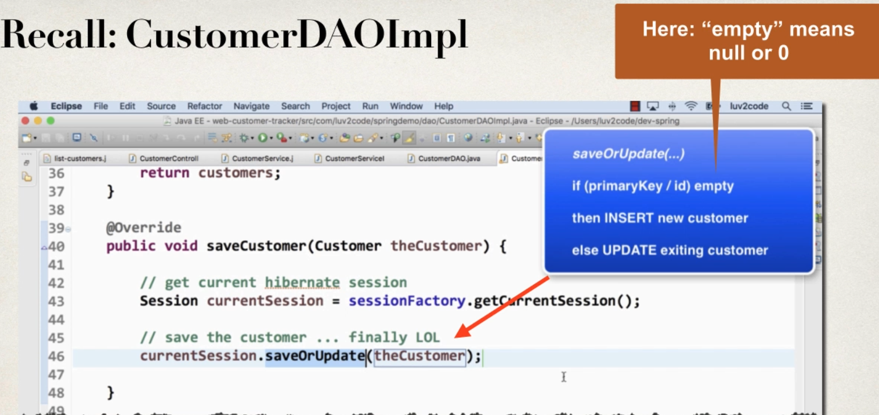

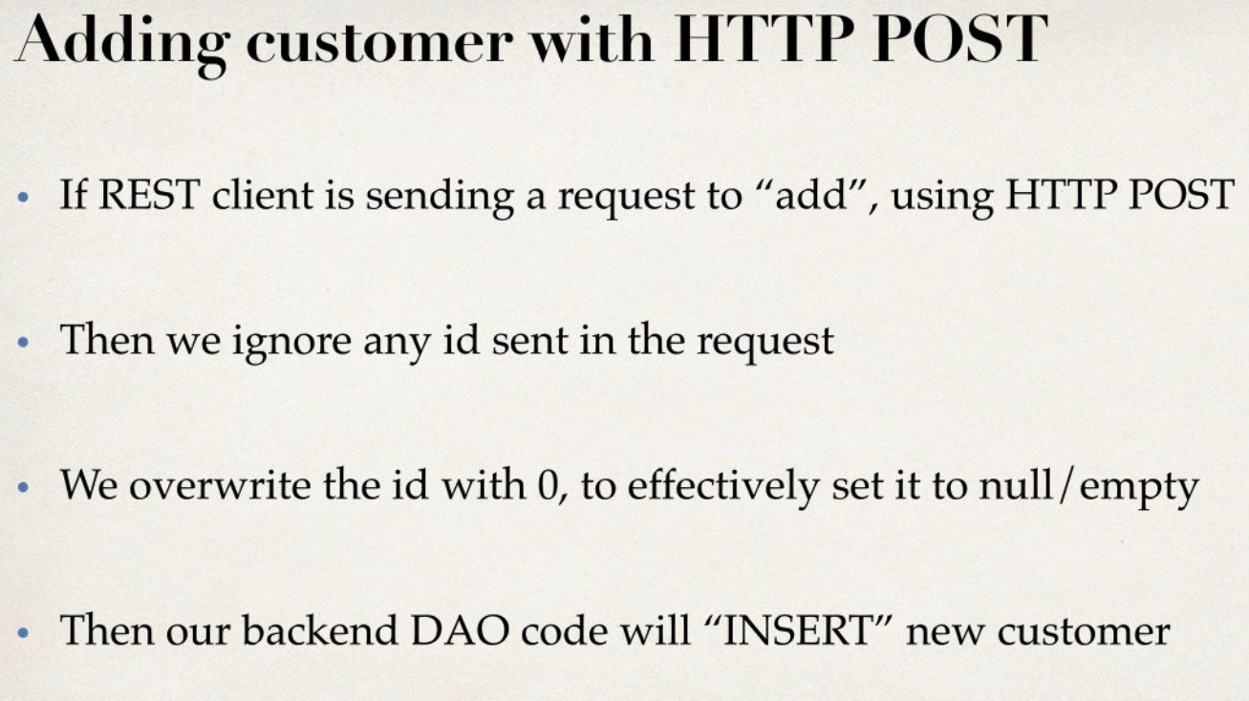

Sending JSON to Spring REST Controller

- when sending JSON Data to spring REST controller

-For controller to process JSON DATA ,need to set a HTTP request HEADER

-content-type:appliaction/json

-need to config REST client to send the correct HTTP request Header

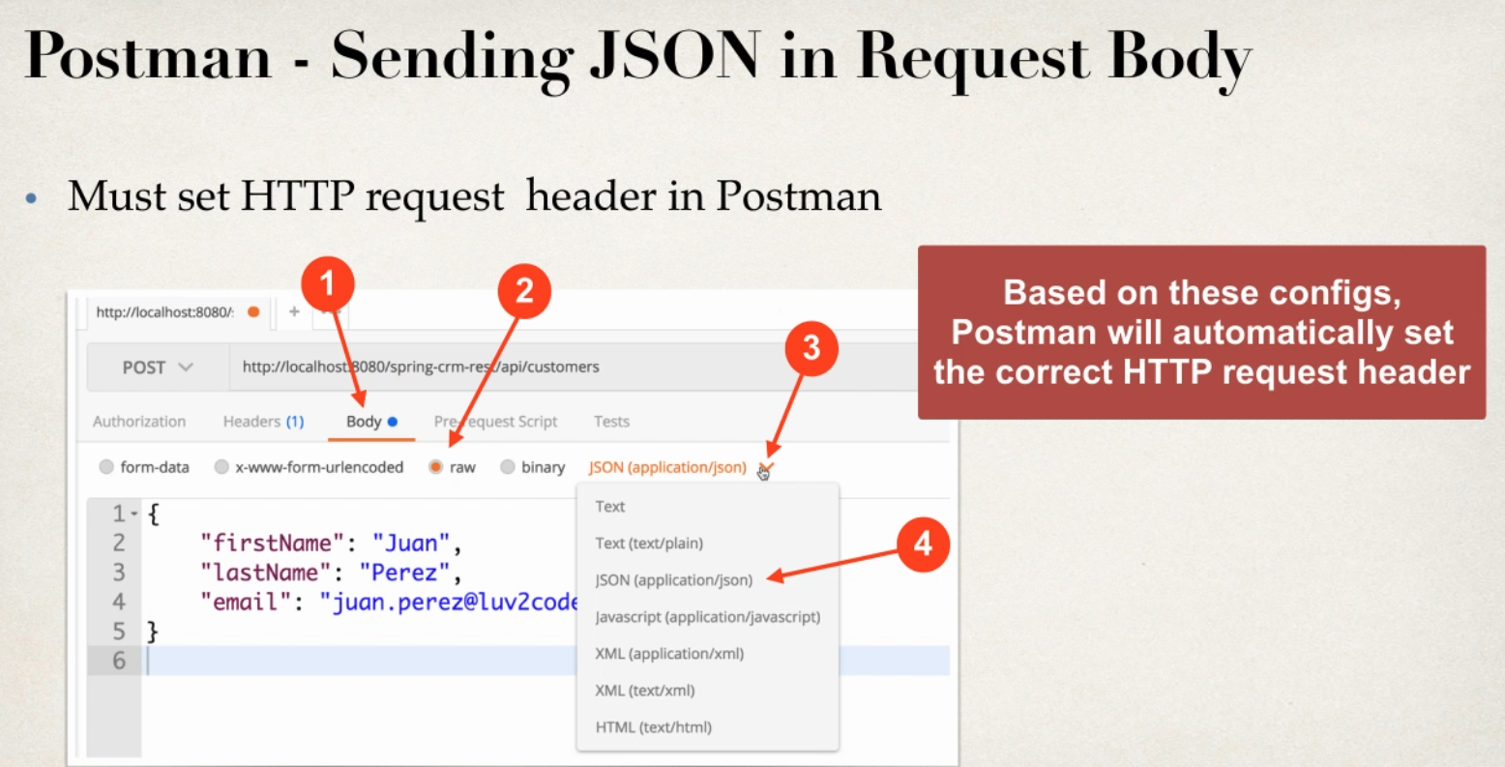

BOTH JSON works

{

"id":0,

"firstName": "sachin",

"lastName": "subramanya H S",

"email": "sachinsubramanya@bcits.in"

}

{

"firstName": "sachin",

"lastName": "subramanya H S",

"email": "sachinsubramanya@bcits.in"

}

CRM UPDATE a Customer

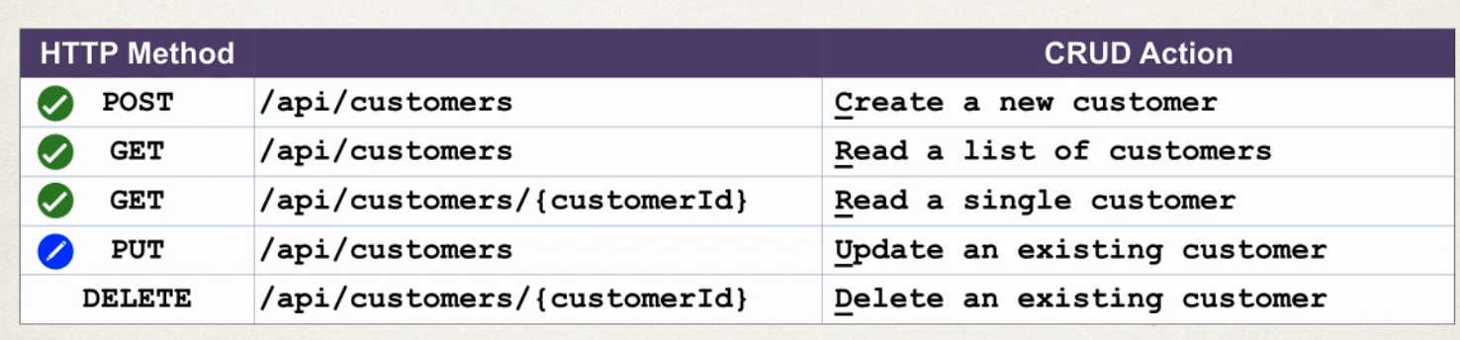

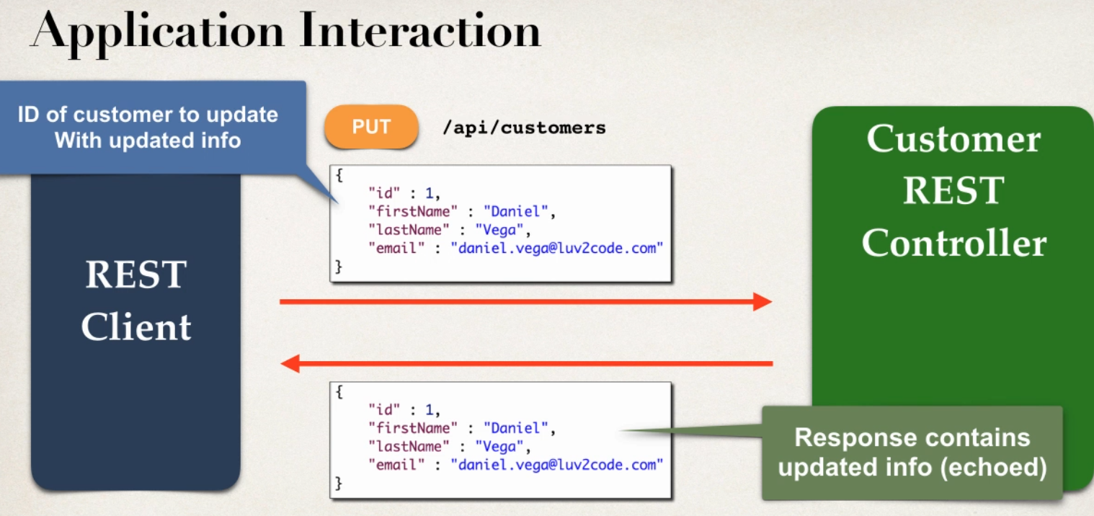

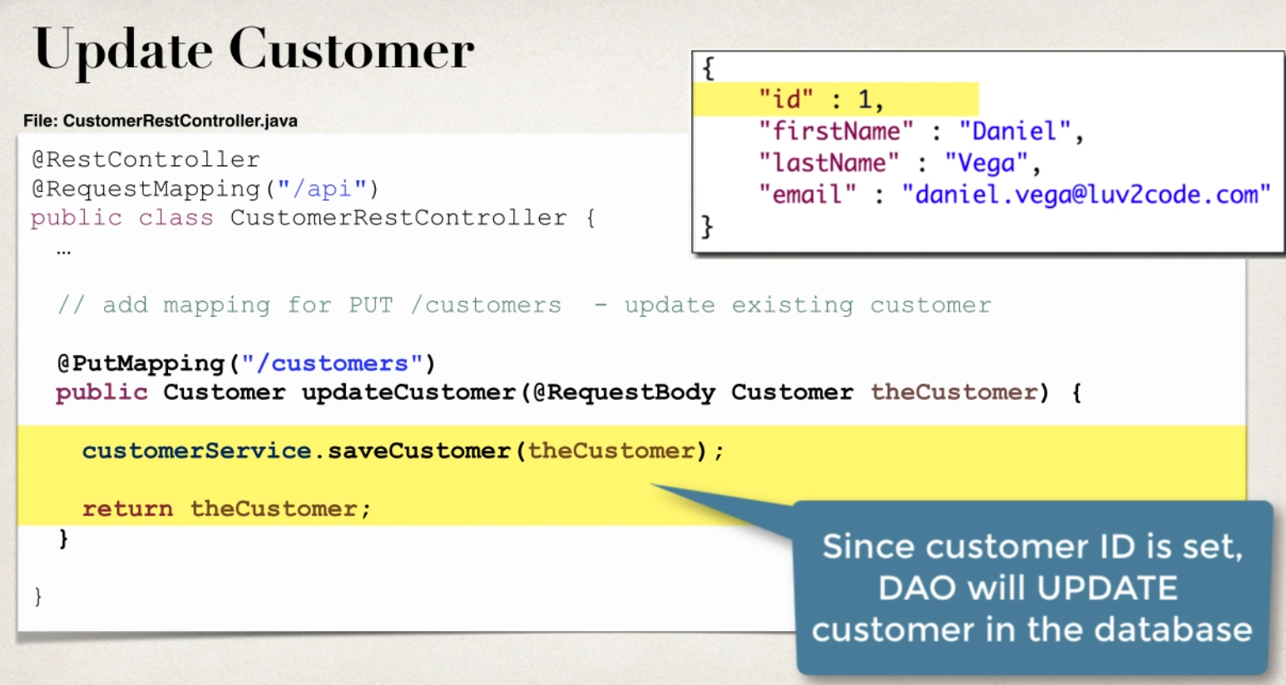

JSON works

{

"id":5,

"firstName": "Dhanvit",

"lastName": "Gowda",

"email": "diyan@gmail.com"

}

SPRING CRM DELETE A CUSTOMER

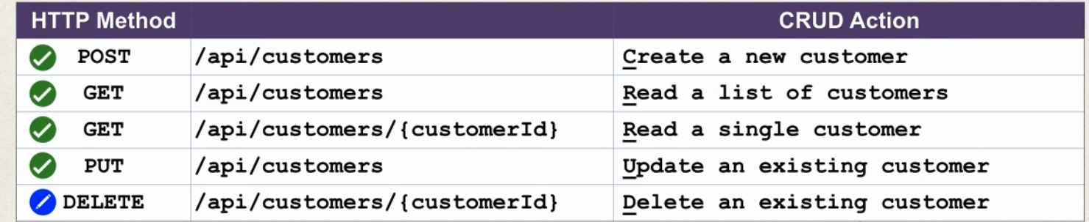

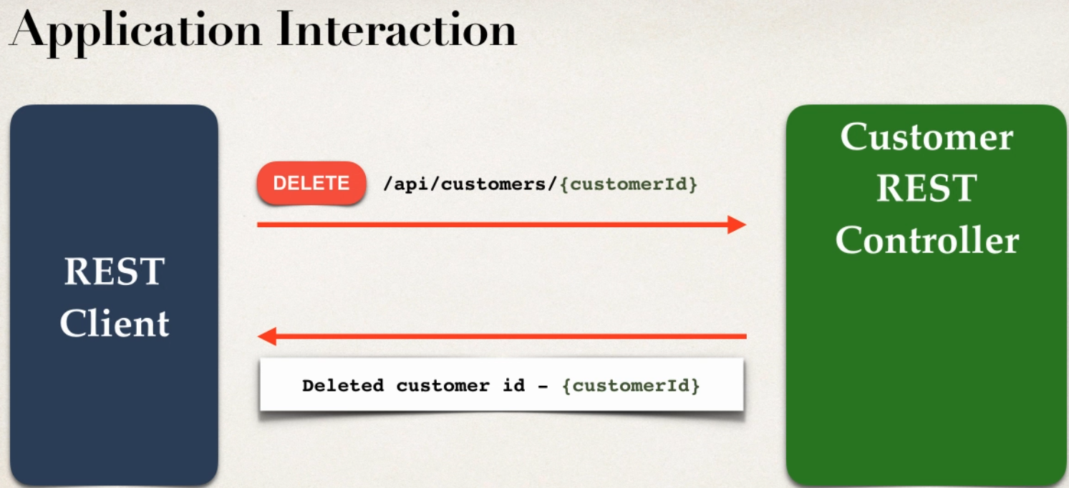

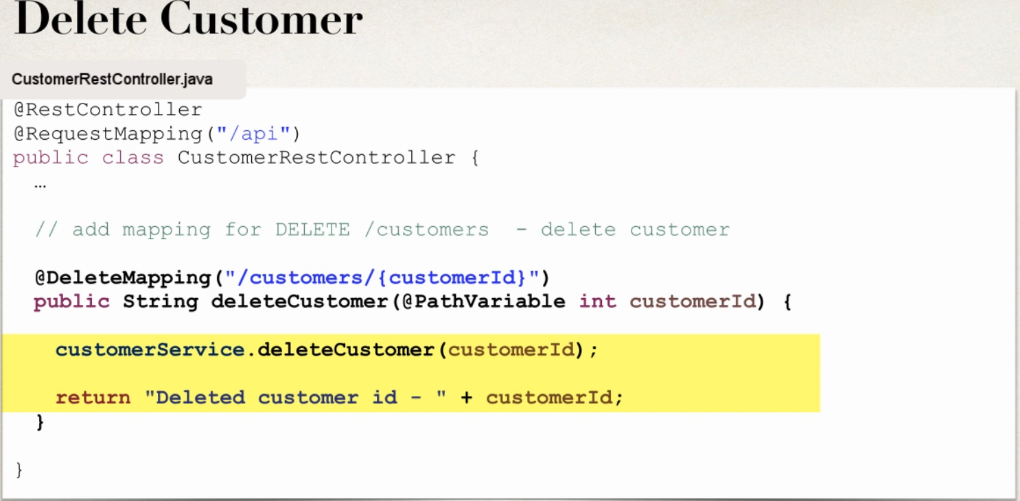

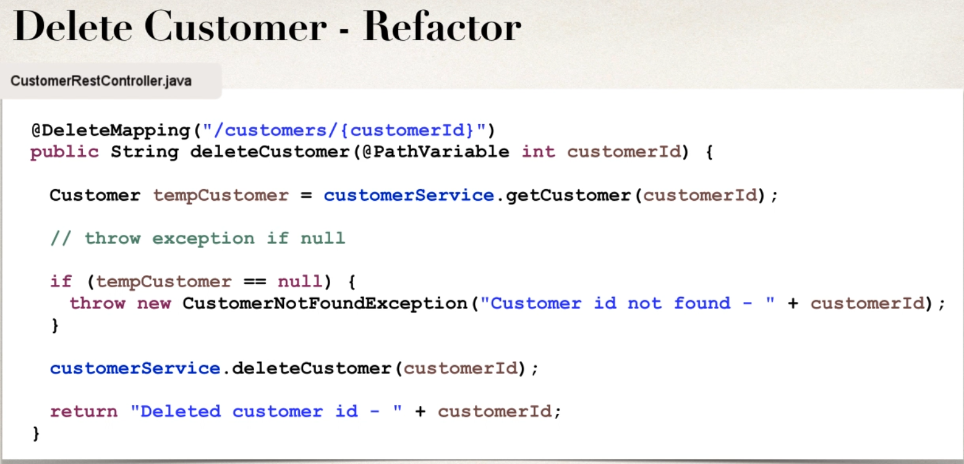

Adding Spring Security to CRM REST API

GOALS

- Secure REST APIs

- Restrict REST APIs based on roles

TECHNICAL APPROACH

- Use Spring all Java configuration (no xml)

- Use Maven for project dependency management

Overview of Steps

1. Add new Maven Dependencies for Spring Security
2. 2. Enable Spring Security Filters

3. Secure REST endpoints

1. Add new Maven Dependencies for Spring Security Open the file: pom.xml Add new entries for Spring Security
2. Enable Spring Security Filters

import org.springframework.security.web.context.AbstractSecurityWebApplicationInitializer;

public class SecurityWebApplicationInitializer

extends AbstractSecurityWebApplicationInitializer {

}

1. Secure REST endpoints

@EnableWebSecurity

public class DemoSecurityConfig extends WebSecurityConfigurerAdapter {

@Override

protected void configure(AuthenticationManagerBuilder auth) throws Exception {

// add our users for in memory authentication

UserBuilder users = User.withDefaultPasswordEncoder();

auth.inMemoryAuthentication()

.withUser(users.username("john").password("test123").roles("EMPLOYEE"))

.withUser(users.username("mary").password("test123").roles("EMPLOYEE", "MANAGER"))

.withUser(users.username("susan").password("test123").roles("EMPLOYEE", "ADMIN"));

}

@Override

protected void configure(HttpSecurity http) throws Exception {

// secures all REST endpoints under "/api/customers"

http.authorizeRequests()

.antMatchers("/api/customers/**").authenticated()

.and()

.httpBasic()

.and()

.csrf().disable()

.sessionManagement().sessionCreationPolicy(SessionCreationPolicy.STATELESS);

}

}

Why disable CSRF?

Spring Security 5 has CSRF enabled by default. You would need to send over CSRF tokens.

However, CSRF generally does not apply for REST APIs. CSRF protection is a request that could be processed by a browser by normal users.

If you are only creating a REST service that is used by non-browser clients, you will likely want to disable CSRF protection.

For more details, see this link:

http://www.tothenew.com/blog/fortifying-your-rest-api-using-spring-security/

Why disable sessions?

For our application, we would like avoid the use of cookies for sesson tracking. This should force the REST client

to enter user name and password for each request. However, this is not always the case depending on the REST client browser you are using. Your mileage will vary here (for example, this doesn't work in Eclipse embedded browser).

For more details, see this link

http://www.baeldung.com/spring-security-session

SAMPLE : <http://localhost:7777/SpringRestSecuirty/api/customers>

Use credential fr browser

Only once it will ask username and password in for login in browser

- without csrf and sessionmanagement also its works fine

4. Test the App with Postman

It is best to test with Postman. Because Postman will prompt for new credentials for each REST request.

1. Run your REST application.
2. In Postman access the REST endpoint: GET /api/customers You will initial get a 401 error: Unauthorized
3. To resolve this, in Postman, click the "Authorization" section of the request.
4. In the "Type" drop-down list, select "Basic Auth"
5. Enter user id: john, password: test123
6. Using Postman send the request again If the user is authenticated, then they'll get the results of REST request. If not, they'll see a 401 error

- From Postman provide username and password in Authorization menu-> Basic Auth it will work fine

5 Secure REST APIs by Role

In this example, we'll secure all REST endpoints under "/api/customers" and adds following security authorizations EMPLOYEE role can perform following

1. Get a list of all customers. GET /api/customers
2. Get a single customer. GET /api/customers/{customerId}

MANAGER role can perform following

1. Add a new customer. POST /api/customers
2. Update an existing customer. PUT /api/customers

ADMIN role can perform following

1. Delete a customer. DELETE /api/customers/{customerId}

1. Open the file DemoSecurityConfig.java Update the file with the code at this link: https://bit.ly/2Lto8HA Make note of the security rules for the various endpoints

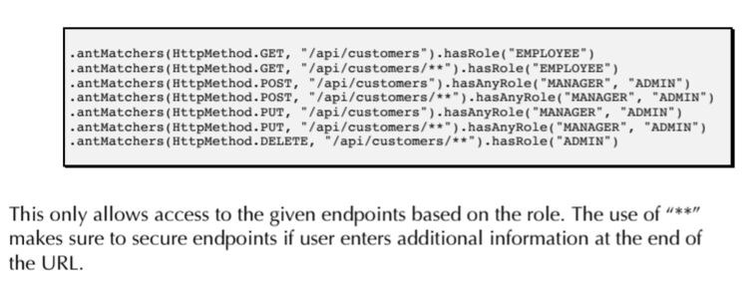

Test With POSTMAN for all login Roles which will work fine